Cheshire East Local Plan Scoping Consultation 2026
  - Cllr Paul Woods (Gawsworth Parish Council)
  - 26th August 2026

These are my personal comments in response to the Local Plan scoping consultation. They are additional to Gawsworth Parish Council’s feedback which I fully support.

Section 1. Introduction and purpose.
- My comments relate to Gawsworth Parish. The Cheshire East ward is also confusingly designated as ‘Gawsworth’ although the majority of ward residents don’t actually live in Gawsworth and around third of Gawsworth residents are not represented by the CEC Gawsworth ward councillor.
  - The population considers the area covered by Gawsworth Parish Council to be ‘Gawsworth’. This is different from the CEC understanding of ‘Gawsworth’. You should keep this in mind when reviewing feedback referring to ‘Gawsworth’.
- Parish Councils should be meaningfully engaged in the development of the Local Plan including the choice of development sites and the development of policies. Engagement and partnership throughout will produce a much better product than producing proposals without real local involvement. Engagement with CEC councillors in no substitute for proper engagement with Parish Councils.

Section 2.2f Why prepare a new Local plan?
- Neighbourhood Plans must be consulted and the Local Plan proposals developed with them at the forefront of considerations. The Scoping document makes little or no mention of Neighbourhood Plans yet they provide an evidenced, high-quality picture of public views and aspirations consistent with the current local plan.
  - Neighbourhood Plans should be identified as a source of evidence and should play a prime role in informing CEC about residents’ opinions in this consultation.
  - The Gawsworth Neighbourhood Plan should form an important source of evidence and feedback to CEC on the drafting of the new Local Plan as it affects Gawsworth Parish. Many Neighbourhood Plans, including that for Gawsworth, have been made recently after wide local involvement and verification. The vision and many details of Neighbourhood Plans remain valid and should carry significant weight in developing a new Local Plan.
    - For example, the vision outlines that Gawsworth Parish will ‘retain its rural character’ and the Village ‘will remain a small peaceful rural village with good connections to surrounding countryside’. Also that ‘Gawsworth Moss will continue to maintain a distinct identity from Macclesfield, but thriving from its connections’ and that ‘Rural Gawsworth will keep its character as beautiful Cheshire countryside based on farming.’ The Neighbourhood Plan objectives include ‘ access to the countryside and green spaces via a wide network of well-maintained footpaths, bridleways and cycle paths’; to ‘improve road safety for pedestrians, cyclists, horse riders and motorists’ and ‘To conserve and enhance the natural beauty of the parish and its environment and the integrity of the greenbelt’
  - Proposed changes in the Local Plan which will affect Neighbourhood Plans should be identified, justified and discussed with Parish Councils before formal proposals are made.

Section 3: Context for the New Local Plan
- 3.7, 3.11 etc. – “Strong reasons to resist development in the green belt” .
  - Clarity on what what would constitute ‘strong reasons’ should be developed so that there can be fairness and consistency in the site selection decisions.
  - Significant change in the character of villages should be considered as a strong reason to resist development. by e.g. large proportional increases in the size of washed over settlements or significant shifts in the nature of housing in a settlement (e.g by large social housing estates rather than mixed housing);
  - Other options should be explored fully before giving up any part of the green belt. These options should be reviewed in partnership with Parish Councils.
  - Building on areas which decrease the green gap between village settlements and towns (eg North of Gawsworth village settlement) should be avoided if possible. Alternative sites which do not significantly affect the fundamental purpose of the green belt exist and could be available even if they have not been submitted under the call for sites.
  - Edge of town developments have considerably less impact on the rural character of Cheshire East than edge of village developments. If areas are taken out of green belt, sites adjacent to towns should be preferred to expanding villages.
    - Sites on the edges of towns are more sustainable.
    - EG expansion of Gawsworth would result in many more car journeys for shopping, healthcare visits, daily school trips etc compared with expansion of Macclesfield.
    - Gawsworth has no active transport link to railway stations.
  - The proposed route, construction work and AGI sites associated with the Peak Cluster Ltd proposals must be considered when deciding on sites to adopt under the local plan.
    - Despite widespread and significant opposition including significant safety and environmental concerns Peak Cluster Ltd are pressing ahead with their business project. So far, no benefits to Cheshire East have been identified. Nevertheless the local plan must assume that the project will proceed when deciding on development sites, traffic management etc.
    - The Macclesfield / Gawsworth Green Belt will suffer to a high degree permanently and during the lifetime of the new Local Plan. This should be taken into consideration when selecting development sites etc.
    - An above ground installation (AGI) is proposed in Gawsworth. The Local Plan should not take this possible development as an excuse to remove surrounding areas from the green belt or designate them as grey belt.
    - No building can take place over or near the pipeline route (distance not yet finalised). Sites adopted under the Local Plan should avoid being anywhere near the pipeline route. There is significant doubt over whether they can be delivered.
    - A site in Gawsworth submitted under the call for sites coincides with the proposed route of the Peak Cluster Ltd pipeline. (fields behind St James Ave and Benbrook Way). (see picture). The Tarmac site in Gawsworth (submitted for employment use) would provide an alternative brown field site for residential use and is of similar size.
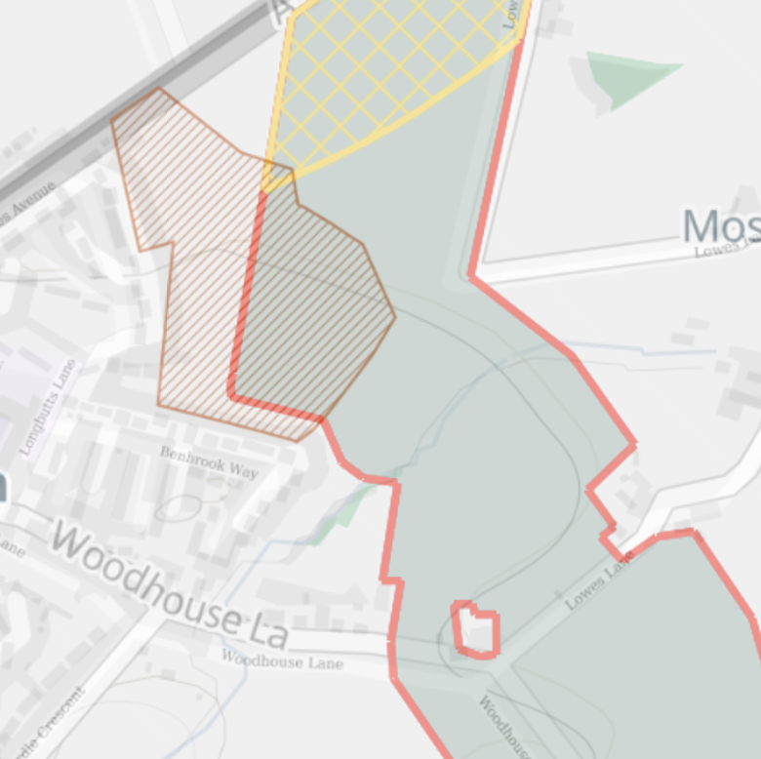
- 3.12 Grey Belt. Preserving the setting and special character of historic Gawsworth should be a prime consideration.
  - The village of Gawsworth comprises the historic conservation area which is linked by a short stretch of Church Lane with the Village settlement with its community facilities including a Community Hub and shop, Play Park, halls etc. Each depends on the setting and special character of the other.
- 3.14 Expansion of villages would not provide good connectivity with railway stations compared with expansion of towns.
  - In Gawsworth, public transport and active travel are not currently viable methods for travelling to Macclesfield or Congleton railway stations for a daily commute or indeed other journeys such as twice daily secondary school trips or travelling to most health centre or hospital appointments.
  - There is no railway station between Macclesfield and Congleton. There are however railway stations north of Macclesfield at Prestbury, Alderley Edge and Adlington signalling that developments north of Macclesfield would provide better connectivity with the railway system.
- 3.15 Brownfield development. The brownfield Tarmac site off the A536 has been proposed for industrial development under the call for sites.
  - This brownfield site appears to be suitable for housing development. It has good access onto the A536 . The Tarmac site is similar in size to the fields behind St James Ave and Benbrook Way which have been submitted for housing use. The Tarmac brownfield site should be prioritised for housing development over any alternative green field/ green belt sites in the area.
  - Note that the proposed area for development is slightly larger than the existing brown field site. It encroaches on a valuable Greenbelt wetland site with bulrushes and reeds, and which is a haven for wildlife. Mature woodland is also included in the expanded proposed site. While recognising the scoping exercise does not consider the details of development proposals planners should keep in mind the environmental harm that expanding brownfield sites can do.
  - Area of call for sites expands the current Tarmac brownfield site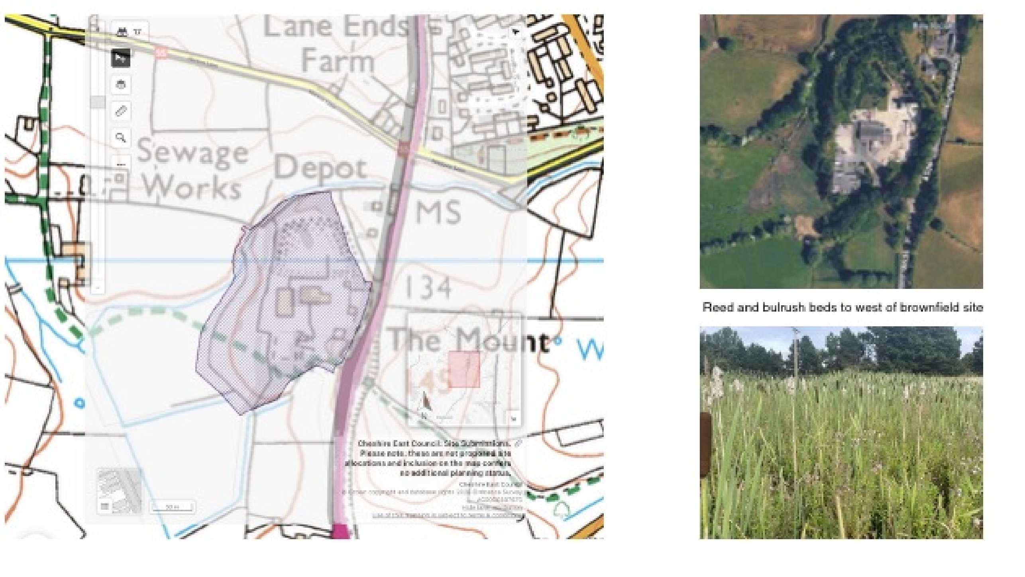

- 3.20 Supplementary Planning Documents. The planning dilemma issues concerning Jodrell Bank and the Consultation zone should be resolved. See comment under 5.129 below
- 3.22. Environmental impacts. Extensive environmental impact assessments have been undertaken in relation to the Peak Cluster Pipeline. These should be consulted with respect to developing the Local Plan. Gawsworth Parish Council has produced its own assessment which has been provided to CEC and should be consulted with respect to any proposed developments in Gawsworth Parish. Also environmental impact reports have been produced in connection with the proposal to develop North Danes Moss. Planners should note that there are significant peat deposits in Gawsworth including North Danes Moss, LPS15, the SSSI and outside these areas.

Section 4: Economic contribution
- 4.7 In mentioning the ‘longstanding scientific research’ and AstraZeneca it is misleading to omit that this has shrunk in recent years, with AZ’s research facility at Alderley Park being lost, and with the decision not to place major investment at AZ Macclesfield.
- 4.11. The recent announcement that research will end at Jodrell Bank should be acknowledged.

Section 4: Heritage Culture and entertainment
- Jodrell Bank should be mentioned as a tourist attraction. This will continue even if research is discontinued.
- Gawsworth Hall should be mentioned as a tourist attraction and venue for entertainment (summer theatre attracts several thousand) together with the surrounding green areas.
- The importance of certain villages, like Gawsworth, to health and wellbeing of large numbers of residents outside the village itself should be recognised and protected. ‘Green venues’ such as Gawsworth are important portals for access to the countryside for the populations of the growing towns. Gawsworth Parish offers important access to the countryside, attractive local facilities like a playpark used by residents of Macclesfield as well as Gawsworth, countryside walks taking in the Danes Moss SSSI and the Macclesfield canal, a picturesque conservation area with important visitor attractions like the ancient hall and St James Church etc. etc. The setting of these assets is critical to their enjoyment by large numbers of Cheshire East residents and developments that adversely affects this should be resisted.
- The footpath network and walking in the countryside should be highlighted as important to residents with an added benefit to health and wellbeing.
- 4.16 agricultural activities.
  - Having recently reasserted the benefits of Cheshire Farms owned by CEC, these should be mentioned as important. Gawsworth has probably the greatest concentration of Cheshire Farms and their continuation is of great importance to our community as well as more widely.
  - Cheshire Farms land must not be viewed as a source of building land that will bring money into CEC. Noting the potential conflict of interest, they should not be offered as development land under this Local Plan.
  - The potential of ‘CEC owned Cheshire Farms to benefit access to the countryside should be mentioned. The land provides an opportunity for CEC, leading by example, to improve access to countryside and make walks safer eg by Fieldside paths, creating new woodland with visitor access and other planting on Cheshire Farms Land etc
  - The importance of small independent farms should be recognised. In Gawsworth we have Newtons Dairy and farm which provides cow to doorstep milk and dairy products. It is crucial to Gawsworth and South Macclesfield and is a great advertisement for agriculture in Cheshire East. Farming businesses such as this must be supported.

Section 5. Scope of the new Plan
- 5.2 – 5.4 Vision and objectives. The Vision Statement and objectives should take note of the Vision and Objectives set out in the Neighbourhood Plans. See Neighbourhood Plan comments above Section 2
- 5.2 – 5.4 Vision and objectives. A high priority should be to minimise the deletion of Green Belt, including designation of Grey Belt. Building on brown field sites and infill within settlements should be preferred wherever possible.
- 5.2 – 5.4 Vision and objectives. Maintaining the character and separation of rural communities and improving the support eg in health and wellbeing should be included. Note that improving deprivation in urban areas is not a reason to deny resources such as those that support health and wellbeing in rural communities.
- 5.2 – 5.4 Vision and objectives. Sustainable travel and active travel should be prioritised when selecting sites for development.
  - Sites on the edges of towns with good active transport links to stations, healthcare and shopping facilities should be preferred over village locations where active travel links are absent. Gawsworth Village settlement has no viable active transport links e.g. to Macclesfield station.
  - Areas within easy reach of stations should be prioritised for development over those which are more remote.
  - ‘Green destinations’ should be identified. These will be communities and areas that are important for access to the countryside, conservation, walking and cycling for pleasure, children’s play etc. Special efforts will be made to support these attributes and their setting. Active transport links to them should be developed. Gawsworth settlement would be one such site which is particularly important, not only to residents, but also to the growing population of nearby Macclesfield.
- 5.8 Identifying and assessing sites. Improved infrastructure should be put in place at the time of building to support the development proposed.
- 5.8 Road access. The A536 passes through the village of Gawsworth. While safety improvements with the government’s safer roads fund have improved safety, it would be unable to cope with large scale development to the south of Macclesfield.
- 5.10. Peak Cluster Ltd Site assessments should include avoiding sites near or coinciding with the proposed route of Peak Cluster Ltd pipeline. Uncertainty over the project is likely to continue through the duration of the plan despite government and Peak Cluster Ltd assurances. Safety concerns will remain if this project goes ahead. Whether these concerns are justified or not, houses will be less saleable in the vicinity of and downhill from the pipeline and especially the AGIs. Gawsworth Village settlement adjoins the planned pipeline route and lies downhill from the planned site for the AGI.
- 5.10; 5.11. Site assessments should determine if suitable access can be gained.
  - For example, should the fields behind St James Avenue and Benbrook Way be adopted in the plan, access from St James Avenue and Longbutts Lane runs past Gawsworth Primary School and would be dangerous and congested. Access direct on to the A536 would create traffic flow challenges and access via Lowes Lane would cut across the Peak Cluster Ltd pipeline route. These problems could make the site unsuitable for adoption (and there is a nearby brownfield option of similar size - the Tarmac site)
- 5.13. It is disappointing that the call for sites for minerals is not being made public at this stage. This results in valuable local information not being available to CEC when assessing the sites. Also, potential new mineral sites could affect the route of the Peak Cluster Ltd pipeline route and AGI sitings so there is a pressing reason for the potential mineral sites to be made public as soon as possible and certainly ahead of the second Peak Cluster and Local Plan consultations later this year.
- 5.15f Green Belt. The Green Belt between Gawsworth and Macclesfield is particularly important to maintain and its character should be preserved. Areas bordering south Macclesfield were removed from Green Belt in the last local plan and the erosion in this area should not proceed further, if at all possible.
  - As well as maintaining the essential purpose of the Green Belt separating Gawsworth settlement from Macclesfield Town, Gawsworth village and the surrounding countryside provide an important destination for access to the countryside and relaxation which is becoming increasingly important to the growing populations of Macclesfield and Congleton.
  - Gawsworth Parish is already under significant threat from the Peak Cluster Ltd pipeline and AGI proposals and stands to suffer more than almost any other parish in Cheshire East.
  - Development in and on the edge of washed over green belt villages such as Gawsworth should only be considered if brown belt sites have been considered and found unsuitable. The reasons why they have been rejected should be transparent.
  - The current borders of Gawsworth Village settlement should not be significantly altered. This is particularly important for the north side of Gawsworth to protect the green belt separation of Macclesfield and Gawsworth.
  - Areas bordering the north of Gawsworth should not be adopted as Grey belt as they contribute to the essential purpose of the green belt separating the settlement from Macclesfield.
  - Adoption of sites as grey belt around Gawsworth settlement should only be considered for small scale development. Larger sites (eg the fields behind StJames/Benbrook) would adversely affect the fundamental purpose of the green belt.
  - Cheshire East Council owns Cheshire Farms sites. Gawsworth Parish has a large number and area of Cheshire Farms sites. They form an important part of our rural community and should not be offered for development in whole or any part. There would be a conflict of interest within Cheshire East were Cheshire Farms sites be proposed as development sites in the new Local Plan.
  - There should be no industrialisation of the land to the south of Macclesfield. This area will be badly affected by Peak Cluster Ltd proposals and the A536 is unsuitable for industrial traffic. Industrial development should be restricted to the areas where it is already present.

- 5.20 Service centres.
If the size of settlements is significantly increased the availability and suitability of local services and facilities should be assessed.
- For example in Gawsworth Village there is a volunteer (mostly elderly) run Community Hub with a small shop which is open part-time. This is adequate for the current village population eg to do top up shopping or to serve 50+ nearby Peaks and Plains housing for those with special needs. It would not be adequate for any appreciable increase in population.
- 5.21 Infill Villages. The concept of infill villages should be maintained. Gawsworth is one such infill village.
- 5.33 f Affordable Housing
  - Any social or affordable housing in Gawsworth Parish should give priority to those with a connection to Gawsworth Parish to maintain family connections, support responsibilities and preserve the nature of rural villages.
  - [Redacted]
- 5.36f. Housing Mix Developments above a few houses should include a mix of social, affordable and market housing. Developments of solely social housing should be avoided, especially in village locations because they would radically alter the nature of the settlement.
- 5.37 and other sections Housing Needs assessments These should be undertaken with the full and active involvement and partnership of Town and Parish Councils from design to interpretation and conclusions. Previously they have not been.
  - The last Housing Needs Survey undertaken for Gawsworth was not undertaken with proper Parish Council involvement and as a result reached misleading conclusions.
  - The Housing Needs assessments must put significant weight on the importance of local (ie within the Parish) family connections to help maintain the integrity of communities.
- 5.39f Housing for older people etc.
  - Gawsworth has 50+ Peaks and Plains rental homes in the heart of the village settlement, close to the community hub and shop. Adding a significant number of social dwellings in the settlement area would cause an imbalance and local services would be inadequate.
  - Gawsworth has a notably older population than Cheshire East and a sizable community of special needs residents. The health and wellbeing needs of rural populations should be evaluated in cooperation with Parish Councils. Support needs should be identified in the Local Plan and delivered in cooperation with local councils, community hubs etc. NB the Tartan Map tool could be particularly unhelpful to rural communities since it is directed towards reassigning health and wellbeing resources towards areas of high deprivation rather than ensuring that each community receives the appropriate support.
  - The Local Plan should include a health and wellbeing delivery plan for rural communities.
  - Improvements to pavements, dropped curbs, slopes etc. Despite the number of special needs residents in Gawsworth much of the village is inaccessible to them because of inadequate provision for wheelchairs and failure to repair pavements from tree root intrusion. Required changes to infrastructure should be assessed where specialist housing is proposed.
  - Any development of social or affordable housing should give priority to those with a true local connection (i.e. within the parish) to benefit from family support. (defining ‘Local Connection’ as anywhere in the borough is at odds with the general understanding of the term and is meaningless in practice.)
- 5.47 Housing diversification and providing for small and medium sized sites.
  - It is important that Parish Councils input their local knowledge on local housing need.
- 5.65f Employment and Economy
  - Employment areas should be suited to the location. Rural locations are suitable for small developments of offices etc in disused farm buildings, whereas science sites are best co-located with similar businesses e.g the Alderley Park science facility.
  - Employment sites should have adequate transport links. Gawsworth and the A536 are unsuitable for carrying additional industry traffic or indeed, large volumes of commuters. There are no active transport links.
- 5.84f Waste Macclesfield waste centre is in Gawsworth Parish. Recent closures of other centres have caused practical problems which the local plan should address, taking account of future increased need created by new housing.
  - The Macclesfield waste centre has proved problematic for recently increased volume of visits. The potential for serious accidents caused by queuing on A536 has been created. A permanent solution for current and projected usage levels should be proposed.
  - Parishes that host waste and recycling centres should benefit from local environmental grants. EG Gawsworth Parish hosts the Macclesfield centre and should benefit from grants for tree and hedgerow planting or similar.
- 5.91f Transport and Infrastructure
Active transport options are lacking in and around Gawsworth Parish making it difficult for future growth to be accommodated in this area if the aspirations for sustainable modes of transport are to be achieved. There are no north – south routes linking Congleton and Macclesfield through Gawsworth.
  - The footpaths in Gawsworth that are currently used for access to the countryside and should be further developed to promote walking for leisure and wellbeing.
  - There is no viable and safe walking or cycling route linking Gawsworth with Macclesfield or Congleton. These should be put in place if any new development in Gawsworth Parish is contemplated.
- 5.96 Natural Environment
I strongly support the role that the Local Plan can play in protecting and enhancing the environment.
  - Gawsworth Parish includes the Danes Moss SSSI and borders North Danes Moss. There are significant peat deposits elsewhere in the Parish. An analysis that identifies sensitive environmental sites in Gawsworth has been prepared by Gawsworth Parish Council in connection with the Peak Cluster Ltd proposals and has been provided to Cheshire East Council. This, together with input from Cheshire Wildlife Trust and others should be included in the evaluation of possible development sites.
  - The Peak Cluster Ltd project will cause significant environmental damage across its routes, around the many installations and in particular in the Parish of Gawsworth, as determined by independent assessments and contrary to the assertions of the Peak Cluster Ltd company. The local Plan must take this potential destruction into account when considering additional developments near to the proposed route of the pipeline and all installations along the route, particularly the AGI planned for Gawsworth green belt.
- 5.99 Hierarchy of local sites and impact on natural assets.
  - The importance of access to the countryside, the richness of the countryside and the benefits to wellbeing should be recognised in the Local Plan. It could be useful in the local plan to identify natural assets such as Gawsworth Village that contribute significantly to wellbeing of residents of the settlement and thousands from nearby towns.
  - The Local Plan should endeavour to support the accessible natural environment. As an example, Danes Moss SSSI is an important local nature asset yet access is impossible for the disabled. Although just off the Cheshire cycle way there is no facility for locking bikes while progressing to the site on foot. There is no facility for parking except ad hoc parking on the verge which destroys the vegetation and overflows onto the narrow road on busy days.
- 5.102 Combatting biodiversity decline. Habitat creation and enhancement.
  - The Local Plan should include proposals to use Cheshire Farm Land for environmental enhancement, access to the countryside, footpath creation and other aspirations set out elsewhere in the scoping document.
    - As an example two main circular walking routes in Gawsworth Parish lead walkers onto dangerous country lanes when adjacent land is owned by Cheshire East and field edge footpaths, edged with new hedgerows would improve safety for walkers, improve biodiversity and be generally good for the environment.
  - The Local Plan should change the Highways policy of preventing planting of trees etc on verges to one where planting is encouraged where it is safe to do so. The current policy is actively inhibiting enhancements to our natural environment.
  - Encouragement and support should be provided to all landowners to make incremental planting, eg in field corners that cannot be accessed by machinery
  - All verge trees that fail should be replaced. As an example several verge trees in the conservation area in Gawsworth have failed over the years, including felling by Cheshire East, but none have ben replaced. This should be extended beyond Highways land to supporting planting by other landowners whose failed trees border highways and PROWs
  - Cheshire East should actively work with Town and Parish Councils to identify opportunities for new planting. An aspirational planting plan should be developed in conjunction with each town and Parish Council.
  - The nice words about enhancing the natural environment need real policies and real action. Use of Cheshire East owned verges and farmland could lead the way if you are actually serious about this!
- 5.104f Health and wellbeing.
  - Health and well being can indeed be influenced significantly by deprivation which should be addressed in the local plan. The ‘Tartan Map’ reaffirms the coexistence of deprivation and health problems and can help confirm areas where green spaces, leisure and cultural facilities etc are lacking. The Tartan Map per se must not however be used beyond its purpose and meaning. Understanding the reasons that drive lower than average scores in individual cells must be fully explored and understood in order to guide policy. The Tartan Map should not be misused to direct health and wellbeing interventions and resources away from rural communities and their health needs. ALL residents of Cheshire East should have equal rights to health and wellbeing support matching their needs.
  - The Local Plan should signal the development of a plan to support rural health and wellbeing. CEC should work with Parish Councils and the NHS to develop and implement this plan.
  - 5.108 Add improving access to the countryside as a deliverable highlighted by the Local Plan. Green spaces, walking and cycling routes and peaceful countryside destinations are important to the health and wellbeing of town residents. Villages rely on towns for GPs, hospitals and other health services but they offer an environment that town dwellers can visit to improve their wellbeing. Gawsworth is one such venue with excellent walks, a playground, duck feeding, an ancient and interesting church, summer open air entertainment etc and set a short distance from the expanding towns of Macclesfield and Congleton. Access to the countryside, identifying green destinations outside but close to towns, protecting their character and providing active transport links to them should feature in future planning policies as an action to promote health and wellbeing.

5.109 Pollution and contamination
- The adverse effects of Peak Cluster Ltd pipeline and AGI proposals during construction and beyond should be noted. Where possible communities affected by the pipeline and AGI construction should not also be subjected to other infrastructure building projects.

5.111 Health and health inequalities
- See comment on 5.104f. Access to the countryside and nearby green spaces and villages is also important.
- Country parks such as Teggs Nose near to Macclesfield are important. The Local Plan should aspire to assess current usage and positioning and aspire to allocate additional country parks or access to countryside walk starting locations etc.

5.112 Active travel
- I support this objective. Active travel opportunities south of Macclesfield are lacking. Only the bravest would cycle or walk alongside the A536 between Gawsworth and Macclesfield. With or without development southwest of Macclesfield and whatever happens with Danes Moss North, safe active travel routes to the south of Macclesfield to Gawsworth and on to Congleton should be identified as a priority.

5.113f Climate Change
- The plan should identify the need for CEC to work with Town and Parish Councils implement measures that will help adapt to climate change and reduce carbon emissions. Parish Councils can’t do much without help and direction from CEC.
- The Local Plan should commit to a plan of extensive new planting, working with Parish Councils and landowners to identify suitable sites and plant trees and hedgerows. Immediate action should be taken to identify Highways verge sites and sites on Cheshire Farms that could safely accommodate new planting.

5.118f Recreation and Community Facilities
- The plan should recognise the importance and need to support facilities in villages near to towns.
  - EG in Gawsworth Pilates classes in the Village Hall attract many from Macclesfield, our Park, community woodland and Playground are visited by Macclesfield residents and Gawsworth Hall mounts outdoor events for the benefit of thousands from across Cheshire East and beyond. In Mottram St Andrew folk concerts in the Village Hall are often sold out with attendees from many miles around.
- It would be helpful to identify the facilities that it would be useful for villages and rural communities to be able to offer. This would be customised to different situations but a ‘shopping list’ could be helpful. CEC could then identify the support they could provide in delivery, work with Parish Councils.
- Support for Community Hubs is vital to rural communities. This can take many forms and can help the hubs to expand the good they do in the community. As well as providing local services the benefit to mental health of volunteer involvement should be recognised. Community Hubs could become the focus for health and wellbeing enhancement but this will need planning and support from CEC.

5.125f Heritage
- I support the heritage protection aspirations. It is important that the setting and surroundings of heritage assets and conservation areas is protected as well as within the boundaries itself.
  - For example in Gawsworth the Peak Cluster Ltd pipeline proposal threatens the waterflow into the ancient fishponds in the conservation area and the unexplored below ground archaeology in the extensive original parkland that surrounds the conservation area.
- Neighbourhood Plans and Parish Councils should be consulted in identifying designated and non-designated heritage assets. It is important that the character of Cheshire East villages is not radically altered by enlargement, building in the green belt or introducing out of character developments.

5.128 Conservation Areas
- The Gawsworth Conservation area analysis has been recently reviewed and approved. It includes reference to the importance of the setting and the surrounding countryside, views etc It should be consulted if any site allocation is considered in the Village.

5.129 Jodrell Bank
- It is high time that the Jodrell Bank policies are reviewed. They are not fit for purpose.
  - The conflicts of interest issues that were apparent in the abandoned SPD should be removed from future policy documents. The last publicly available SPD draft made some attempt to introduce evidence-based determinations of effects on the telescope operation but also showed a blatant and unacceptable Conflict of Interest and lack of independence with respect to the University of Manchester. Please see my previous communications with CEC on the matter.
  - The existing situation where the University effectively has a veto over developments, which need not be independently scientifically verified, distorts objective evaluation of development sites by CEC planners and is of questionable legality and potential actions.
    - Assessments of the effects of proposed developments on the operation of the telescope must be subject to independent expert scientific review. University of Manchester have previously ‘objected to everything in the consultation zone’. Their objections have not been evidenced based or independently verified. Sites which have little or no realistic effect on the operation of the telescope have been objected to. The University of Manchester veto has resulted in the unnecessary loss of small, affordable housing units in Gawsworth and no doubt elsewhere.
    - Notwithstanding the designation of Jodrell Bank as a world heritage site, recent announcements about halting the scientific work there shows that it may not be as crucial as we believed. The Local Plan should accommodate a future where Jodrell Bank is an important tourist attraction that should be preserved and possibly expanded rather than a centre for scientific research.

5.131 Design
- A borough wide design code is clearly inappropriate given the wide diversity of settlements across Cheshire East.
- Neighbourhood Plans and Town and Parish Councils should be consulted with respect to locally specific design matters.
- Housing density. High density housing in village locations would fundamentally alter the character of villages and should not be permitted

5.144 Existing Evidence
- Neighbourhood Plans should be listed as existing evidence that should be considered in developing the new Local Plan.

Section 6. Engagement Strategy
- While understanding completely the circumstances which lead to CEC progressing with all possible speed in the current consultation it has meant that there has been insufficient time for Parish Councils to debate and engage fully with their residents over the principles raised in the scoping document and to prepare a response which has been fully thought through and properly reviewed.
  - Future consultation exercises should a) allow more time for public review and b) permit challenge of some of the principles emerging from the scoping review.
- 6.31 Role of Elected Members
  - Town and Parish Councils must be formally involved in representing communities. Involvement of elected members as described is not sufficient to ensure that the plan reflects local priorities and that decisions are informed by community views.
- 6.47 Community assemblies. These are a welcome innovation however the same content and discussions must be had with town and parish councils at the same time. Community assemblies are additional and members are inevitably self-selected and likely to have particular angle or interests that they wish to pursue. Community Assemblied do not and must not replace full and proper engagement with Parish Councils which are the democratic representatives of residents.
- Openness and proactive sharing of information is essential. It is sometimes necessary to submit Freedom of Information requests to CEC to obtain information that should have been shared with Town and Parish Councils and the public. CEC should commit to the maximum possible openness during plan development to engender trust and avoid being bogged down with FOI requests.

Stakeholders
6.62 Elected members, town and parish councils are indeed stakeholders but they take on special status as the democratic elected representatives of the people. As such I believe their special responsibility should be highlighted rather than simply being listed as one amongst many stakeholders.

