01 September 2026

Re Cheshire East Local Plan Consultation

This response is submitted for and on behalf of the British Horse Society (BHS); local representatives may also submit responses.

Authority | Cheshire East
Consultation | Local plan scoping consultation | Cheshire East Local Plan
Closing Date | 01 September 2026
Response to | Localplan@cheshireeast.gov.uk
Submitted by | [REDACTED], British Horse Society Access Field Officer North and North West
Submission date | 01 September 2026
Summary
Request for inclusion of equestrian routes in strategic planning | As representatives of the equestrian community, we would like to request that all equestrians – both horse riders and carriage drivers – must be included as a formal consideration for all planning applications.  This should be a prerequisite where the development:  - Directly affects the equestrian rights of way network or access to it  - In locations that directly abut equestrian properties  - Where there is little or no provision (a gap in the network) for equestrians  - Where connections will be improved for other vulnerable road user groups to and from the new site/traversing the new site  - Involves active travel improvements  - In road, rail or waterway crossings  We should be included in planning as a default, in the same way that walkers, wheelers and cyclists are.  We would like to be added to the stakeholder list for all development consultations using [REDACTED] as the contact email address.
Background
Who we are | The British Horse Society is the UK’s largest equestrian charity, representing the UK’s 3.2 million equestrians. BHS welcomes further discussion regarding active travel routes in terms of dimensions, surfaces and signage https://www.bhs.org.uk/go-riding-and-learn/access-and-bridleways-advice/
Why we are responding | We would like to request that horse safety and equestrian access remain in these strategic plans with the challenges detailed in the RoWIP kept in mind when planning new access.  These equines are loved by and relied upon by their riders/handlers for the shared joy in the ability to exercise in open spaces, leading to improvements in wellbeing on both sides. Given that horses are evolutionarily nomadic creatures, their motivation to travel and explore is strong, so better access to safe travel routes will have positive effects on equine welfare too.  Ridden horses can safely share many existing cycling and walking routes within the area where users are separated from vehicles, so it is imperative that equestrians are also included in multiuser paths, green infrastructure, NMU routes etc to avoid creating dead end routes or sandwiching horses and riders between cyclists and MPVs/HGVs. With a fragmented and limited bridleway and byway network, the establishment of Active Travel/multiuser access routes present an opportunity to share this off-road provision with a wide range of vulnerable road users – equestrians, wheelers and pedestrians.  Where an off-road path is being constructed, it is in the public interest to be multi-user as leisure as well as amenity use will be made of it.  Several categories of public rights of way (bridleways, restricted byways and byways) and minor public roads are already shared by cyclists and other user groups. Thus, as a general principle, we believe that, for maximum public benefit and fairness, the reciprocal approach should be implemented, i.e. that new or improved local access routes should be shared with all user groups. We ask that wherever possible, horse riders and carriage drivers should not be excluded from multiuser routes, ensuring fairness for all users.  Overarching policy documents such as this should be fully inclusive, and reflect national policy, as they directly affect decisions made in planning and development.  Horses would once have been a common sight in all urban areas, providing transport and services. Much of the infrastructure developed around them, but with the increased use of motorised vehicles, and restrictions on the status of offroad alternatives, equestrians are increasingly limited I their ability to travel around the area, for leisure or utility.  When considering road layouts that protect vulnerable users, horses should be included with them, not pushed on to the highway by them or sandwiched between the protective measure and the highway. In more rural or on urban perimeters, crossings (including level crossings, pelican crossings, underpasses and bridges) should by default include equestrians. Where there is doubt over suitability, the BHS should always be consulted as guidelines are simply that – they are not regulatory, and we can often advise how to adapt to meet restrictions in a particular location. This is especially important where our offroad routes meet a barrier in the form of trunk road, railway, river or canal.
Relevant Statistics and References that can be quoted
Number of horses in affected area | There are 15536 equines registered to addresses in Cheshire East (DEFRA, 2024).
Communities we represent - Gender | 88% of adult riders are women, 85% of children who horse ride are girls (Sport England, 2023). Conversely, most cyclists identify as men and boys.  Failure to accommodate riders in Local Travel facilities, especially where they are free from motor traffic or segregated, has greater impact on women and girls as more females ride and more are injured on the road in incidents involving motor vehicles.
Communities we represent - Age | 37% of responders to our 2010 study were over 45
Communities we represent – those with mobility challenges | Horse riding and carriage driving allow individuals living with pain or disability to access green spaces and community amenities that otherwise may not be accessible to them. Many senior citizens living with lower limb arthritis for example, can exercise on horseback but cannot walk or cycle far enough to get the movement benefits from these modes, or indeed get to the open spaces that many routes provide access to.
Safety Concerns (General) | The BHS considers horse-related traffic collisions to be significantly under reported, to it, to the police, or any other body. This is supported by research by Danica Pollard and John Duncan Grewar, Cars dent, horse riders break: Analysis of police-recorded injury incidents involving ridden horses on public roads in Great Britain (Journal of Safety Research, Volume 84 2023, p86-98) which made the points:  - 1,031 injury incidents involving ridden horses with 2,243 road users  - 1,187 road users injured, 81.4% were female, 84.1% were horse riders  - 238/267 serious injuries and 17/18 fatalities were horse riders  Even with this underreporting in mind, BHS statistics for 2025 still show that there were 2,810 road incidents involving horses, 59 horses have died and 82 have been injured, 86 people have been injured because of road incidents, 83% of incidents occurred because a driver passed by too quickly  A serious road incident not only causes distress to those involved but costs the public purse £2.7M (DfT, 2024) therefore safe off-road access and improved road safety are fundamental in any new development.  The Highway Code revisions recognise the vulnerability of equestrians as equal to that of cyclists, and so they should be given the same consideration. This is not only relevant to horse riders but also to carriage drivers, who are very poorly supported in terms of safe or offroad access in most areas.  Below is the BHS Incident Map. You can see just how many road incidents are reported to the organisation; and this really is just the tip of the iceberg as not everyone reports via the Horse iApp  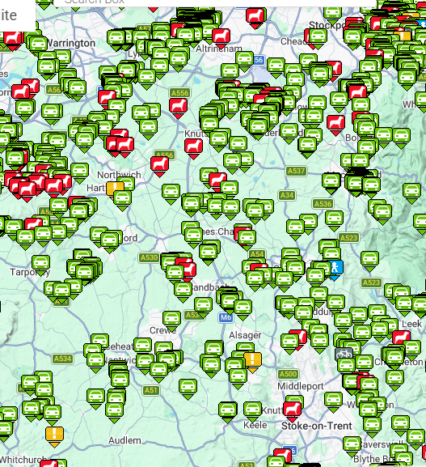
Economic Considerations | The BETA data (2023) states that the economic contribution per horse is £6,887, so the equestrian community in therefore contributes approximately £106,996,432 per annum total predominantly to the local economy. It makes good economic sense therefore to include equestrians in development planning to sustain the businesses and services relying upon them such as farriers, vets, feed merchants, etc.
Health and Wellbeing Considerations of Equestrian Activities | Horse riding is ‘moderate intensity’ exercise (NHS Heath Survey for England (2016, p34). 24% of people involved in equestrian sport have a disability, so it is an activity that is accessible and can enable people to enjoy the outdoors.  Indeed, an appreciable percentage of the equestrian community is aged 60+, who maybe cannot walk, run or cycle due to age related issues that prevent high impact/intense cardiovascular exercise, but owing to the steady state nature and non-weight bearing nature of horse riding or driving, they can still gain the benefits of exercise and access open spaces via this method of travel.  Many disabled individuals or those from older generations would be able to gain the mental health benefits of open spaces via horse and carriage if more allowance was made for them.  Of the 37% of responders over 45, most of them stated that they wouldn’t exercise if they didn’t have a horse.
National Policy | The NPPF para 105 states: ‘Planning policies and decisions should protect and enhance public rights of way and access, including taking opportunities to provide better facilities for users, for example by adding links to existing rights of way networks…’.  One of the comments frequently received by the BHS is that horses are not considered in Active Travel, and this is why they are not considered in local access and travel plans. Jesse Norman MP, Parliamentary Under –Secretary of State for Transport in a House of Commons debate on Road Safety, 5 November 2018 (1) stated: “We should be clear that the cycling and walking strategy may have that name but is absolutely targeted at vulnerable road users, including horse-riders……Horse riders are vulnerable road users—there is no doubt about that, and there never has been—and they have been included in the work we are doing.”  ATE state in their 2024 guidance: Horse riding is explicitly included in active travel: House of Commons Transport Committee Active travel: increasing levels of walking and cycling in England Eleventh Report of Session 2017–19 Report, together with formal minutes relating to the report (London, 2019): “Active travel covers any journey that is made by physically active means, and covers such diverse activities as horse riding, skateboarding, roller skating, and riding a scooter.” p6.  The British Horse Society has an MoU with Sustrans detailing how cycleways can be shared with equestrians, and work is ongoing with other organisations to agree use of their land/facilities.
Equestrian Requirements & Guidelines
General Requirements/Considerations for equestrian activities | Circular routes are preferable for leisure, to decrease fragmentation. Identifying gaps and providing connecting routes (permissive or dedicated) avoids the scenario where equestrians are excluded from an area, and is vital where, for example, a bridleway changes to footpath at a parish boundary or road crossing.  This plan should include horses on any circular multiuser trails allowing the opportunity for wheelchair users, cyclists and horse riders to enjoy a traffic free leisure route.  Signage is key for shared use paths and PROW to clearly identify the lawful users and status of the path., sufficient signage will avoid conflict between users and avoid users deviating from the routes.  Maintenance and enforcement differs between PRoW and other types of paths, however there will be maintenance requirements for these ‘high-level’ routes and a knock-on effect for increased use of PRoW, greenways, etc leading to and from the Active Travel routes. With budget constraints, it is important that the authorities involved are committed to resource the additional use of the existing network and the development and maintenance of the additional routes.
Access Controls | Access Controls should be accessible to all legal users, but it is worth noting here that anything that is usable by wheelchairs/mobility scooters is also usable by horse riders, which makes considering riders much easier and giving them permissive access if not legally dedicating higher use.  RBs are more frequently sited as challenging when restricting access to illegal users, but any access control measure should permit the passage of carriages.  It would be appreciated if consideration could be given to horsebox parking at access points to the main equestrian routes in the borough and any beaches that equestrians can use.
Surfaces | We encourage the use and maintenance of natural surface wherever possible. Other surfacing options, such as bound rock rubber crumb, have been proven to work well on other well-used and rural routes, whether flat or on steep gradients. The surface is porous, non-slip, less concussive than sealed surface materials and long-lasting. Where a bridleway or Restricted Byway is going to be utilised by a cycling trail and the change in status is accompanied by plans to resurface, this should be taken into account, and tarmac avoided. Likewise, when permission is sought to resurface private roads/drives, tarmac alternatives should be advised.
Active Travel Schemes | Horses should be mentioned specifically alongside other users where you reference Active Travel Schemes. As you will see above, it is intended that they are part of this scheme. Not only should new routes include them, but current routes must be reviewed to allow access, especially where they link bridleways and byways.
Vulnerable Road Users | We thank you for considering equestrians within the plan as vulnerable road users. We very much appreciate that horses have been highlighted in this paragraph.  We welcome any inclusion in safety schemes, and I have included above some considerations for this.
Road Improvements | Please could horses be included/considered in road improvements. Road infrastructure designed to protect vulnerable road users should treat horses in the same way as cyclists and pedestrians; as demonstrated by the statistics above, equestrians are vulnerable when forced to mix with motorised vehicles. They should not be forced into a situation where they are passed by vehicles on one side and cyclists on the other.
Canal towpaths | Wherever visibility allows, and space is similar to shared PRoWs, horses should be allowed access to the canal towpath network as they often provide sound links between destinations, as well as good routes for exercise in their own right.
Road crossings | There are two elements to consider in which the DMRB ‘Pegasus’ is over-engineered for the majority of sites:  - Length – a segregated dual crossing for riders next to one for pedestrians and cyclists is rarely necessary and doubles cost for no purpose since it is rare that there will be so many pedestrians, cyclists and riders waiting together.  - Width of verges – limited extent of highway may preclude the corrals and waiting areas of the DMRB. We accept offsetting call controls for riders along the bridleway rather than trying to create a corral, in fact, this has advantages over the DMRB specification.  As you will see in the Advice note I mentioned, Road crossings, where sites make it necessary, we will accept just a call control at rider height on a non-Pegasus standard crossing, ideally set back from the kerb by a horse’s length, but where we have had pushback on that because of electrical supply, making the pedestrian pole higher with a rider control at pedestrian head-height is better than excluding riders from the crossing completely as using a kerbside control is lower risk than crossing without stopping traffic.
Cycle network and promoted trails | Please could you include horses on any offroad sections of the National Cycle Network  Please could horses be included in your considerations regarding promoted trails
Equestrian Access Strategy | Equestrian population density and priority routes are currently being plotted by the BHS team. Below are the routes we believe have possible higher rights which will help with connectivity.  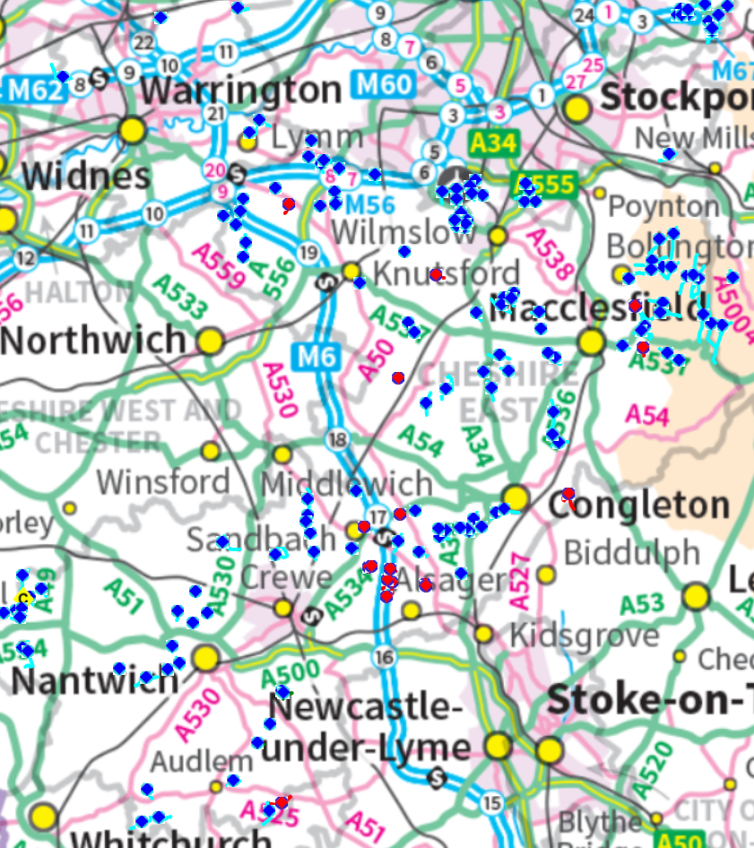
Summary | Jesse Norman MP, Parliamentary Under –Secretary of State for Transport in a House of Commons debate on Road Safety, 5 November 2018 (1) stated: “We should be clear that the cycling and walking strategy may have that name but is absolutely targeted at vulnerable road users, including horse-riders……Horse riders are vulnerable road users—there is no doubt about that, and there never has been—and they have been included in the work we are doing.”  It would be useful to include routes that include wheelers and equestrians on your maps. Clearly Wheelers are considered as otherwise this would be a highly discriminatory policy; what is implied should be stated for clarity.  Equestrians should have the same consideration as vulnerable users and active travel participants as all of the other user groups mentioned here. As mentioned in the introductory statements of this document, exclusion of horses discriminates against women, girls, less able bodied and older members of the population. It should me mentioned here also that highway design guidance and BHS guidance is simply that – guidance. Even if not ideal, equestrians will gladly accept any measures that avoids them having to share highways with vehicles. The BHS should be consulted whenever new infrastructure is considered that helps users cross barriers such as rail, road or river, or takes horses off roads. We will be able to help you to produce a workable solution.
Useful links | The BHS guidelines for inclusive access for horses can be found at: https://www.bhs.org.uk/go-riding-and-learn/access-and-bridleways-advice/

[REDACTED]

