From Rev Nancy Goodrich. Vicar of Bollington.
I am Vicar of Bollington. Bollington Parish Church of St Oswald’s is a Grade 2 listed heritage building on Bollington Road. This road, which is within a few metres of the building, is already very busy. I am concerned about the traffic impact of any further housing developments. All traffic, construction and domestic, will pass the church. We are next door to Bollington Cross Primary School and just along from the Cock and Pheasant pub.
Data from the Town Council SID measurements show that there can be up to 300 vehicles / hour on Bollington Road outside the church with over 2000 vehicles per day exceeding the 30 mph speed limit outside the school pick up times.
The impact on church is that we already suffer with traffic noise and vibration inside. The large and beautiful windows that face the road are a mixture of stained glass and leaded panes and are unable to be soundproofed.
The church does not have a car park; we are reliant on partial use of the school car park during weekends and holidays. At all other times all the parking is on the road and the parallel parking spaces across the road.
On a daily basis I, and other church users, have to park with large trucks passing the car door within inches, on the outside of a bend, and faster than 30 miles per hour. We regularly have near misses. We have elderly and disabled midweek congregation members who cannot quickly jump into cars without the doors being wide open. There is a pedestrian crossing, but there is a large grass verge instead of pavement next to the cars, which the infirm and pushchairs can’t cross. We have a busy toddler group midweek and getting children safely into cars is a challenge. We regularly have hearses parked on Bollington Road for funerals and the volume and speed of traffic already affects the dignity and safety of mourners who are usually unaware of what is happening around them on the road.
Paragraph 5.112 of the consultation document states that “creating safe and secure places is essential to sustainable communities and paragraph 5.114 states that “The Local Plan will need to encourage active travel both in new developments and existing areas”. We have many congregation members and other church users who walk to the church. The pavements down the main Bollington Road are very variable in their safety and width with a lack of safe crossing points. There is lots of overhanging vegetation. With more housing proposed in the Lowerhouse area we would expect even more people to walk to us up Moss Brow which is very narrow and unsafe for pedestrians to share with cars. These factors already put people off attending and traffic growth from further development would significantly harm the community use of our heritage building. There needs to be a review of the effect of proposed developments on Albert Rd on the safety of all road users of Bollington Rd, Moss Brow and Albert Rd.
I am very aware that young adults In Bollington who would like to continue living here struggle to find affordable housing. And I would not say don’t build anything. Affordable housing must be part of any development. However I ask that the particular issues facing Bollington Parish Church be documented in the Local Plan with the expectation that funds would be allocated to improve safety of pedestrian routes to church and change the road layout to provide safe car parking for church (eg creating perpendicular car parking rather than parallel would be safer for people).
I ask that the section of Bollington Road outside the church and the school (and extending to the junctions of Flash Lane and Moss Brow) be redesigned to reflect the significant pedestrian community gathering place and community centre that it is, rather than regarded as and looking like merely a through access road for all traffic into Bollington. This section of road could be considered for a heritage enhancing road treatment based of the recommendations of the study ‘Reclaiming the Road’ carried out for the Town Council by Civic Engineers after the 2018 version of the Neighbourhood Plan (see figure below). This scheme involved narrowing the roadway and widening pavements to provide flexible pick-up / drop-off regions for the school and church. A heritage-enhancing surface of cobbles or similar outside church could be considered. Double yellow lines would be detrimental to the heritage, traffic would flow faster and the reduction in parking would severely affect the community’s ability to use the heritage building.
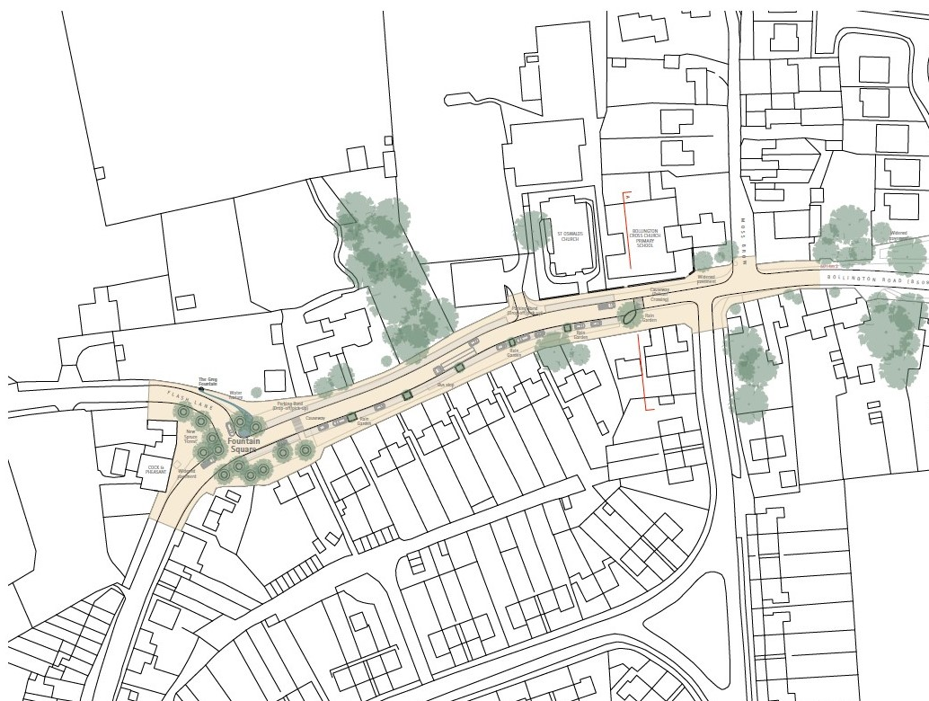

Bollington Road Improvement Proposals by Civic Engineers 2018

