FORMAL REPRESENTATION & OBJECTION
CHESHIRE EAST NEW LOCAL PLAN
Henbury • Whirley • Sandy Lane • Birtles Road, Macclesfield

SCOPING CONSULTATION DEADLINE
5:00 PM – TUESDAY 1 SEPTEMBER 2026

Position: I object to the potential residential allocation of the submitted land in this locality on the evidence presently available. The sites should not progress unless Cheshire East first demonstrates, through published evidence, that they are necessary, suitable, sustainable and deliverable.
This representation gives particular weight to the former Sandy Lane / Whirley Quarry landfill because official records already establish the existence of a permitted landfill and Cheshire East's own historic site-assessment evidence recorded land at Birtles Road as being directly on landfill.

Executive summary: the principal grounds of objection
- Historic landfill / industrial-waste risk: Environment Agency public-register data identifies BROCK LIMITED at Whirley Quarry, Sandy Lane, under permit KP3092CX (pre-EA reference 53470), classified as a landfill taking non-biodegradable wastes. Cheshire East's historic SHLAA assessment for land west of Roewoods Farm, Birtles Road (ref. 3312) stated 'Located directly on landfill' and required consultation with the Contaminated Land Officer.
- Potential leachate, groundwater and landfill-gas pathways: the question is not merely whether a housing boundary overlaps a mapped tip boundary. The Council should establish whether leachate, contaminated groundwater or landfill gas is present or capable of migration through surrounding ground before residential suitability is assumed.
- Ecology: Cheshire landscape evidence describes Sandy Lane Pit as a derelict landfill with ponds and terrestrial habitat supporting a large number of amphibians including great crested newts. The wider area contains hedgerows, trees, grassland/pasture and ponds capable of functioning as connected habitat for bats, birds/owls, badgers and great crested newts.
- Housing requirement versus new land: the new standard-method minimum is 2,530 homes per year, but this is not automatically the amount that must be placed on newly allocated greenfield or Green Belt land. Existing permissions, allocations, construction, brownfield capacity and windfalls must be transparently accounted for.
- Delivery: Cheshire East reported 8,780 deliverable homes at the 31 March 2025 base date, equivalent to 3.3 years against a five-year need of 13,162. The Council should distinguish a deliverability/build-out problem from a pure shortage of identified land.
- Employment: Cheshire East says average annual jobs growth from 2010 to March 2024 was 1.3%, versus the current plan's 0.7% assumption, while around 375 ha of employment land remained available. The new Plan should show where future Macclesfield-area jobs will actually be and the commuting consequences of housing growth.
- Infrastructure: schools, healthcare, roads, public transport, waste, electricity, water, wastewater and drainage must be assessed cumulatively with already-permitted and under-construction housing.
- Green Belt, landscape and heritage: several nearby parcels considered together could create a major urban extension, affecting settlement separation, countryside character, agricultural land and the setting of Grade II* Whirley Hall.
- Consultation: the scoping consultation runs from 21 July to 5pm on 1 September 2026. Given the scale and complexity of the issues and the summer-holiday timing, I ask the Council to explain how residents immediately adjoining concentrations of submitted sites were engaged and to ensure proactive notification at later site-allocation stages.

1. Status of this objection and the Call for Sites process
I recognise that the current exercise is the New Local Plan Scoping Consultation and that Call for Sites submissions are not allocations or planning permissions. My objection is therefore directed at the potential progression of these parcels towards residential allocation without the evidence identified in this representation being completed, published and considered.
Evidence source: Cheshire East, New Local Plan page and 21 July 2026 scoping-consultation launch: consultation 21 July–1 September 2026; current stage concerns the scope of the new Plan.
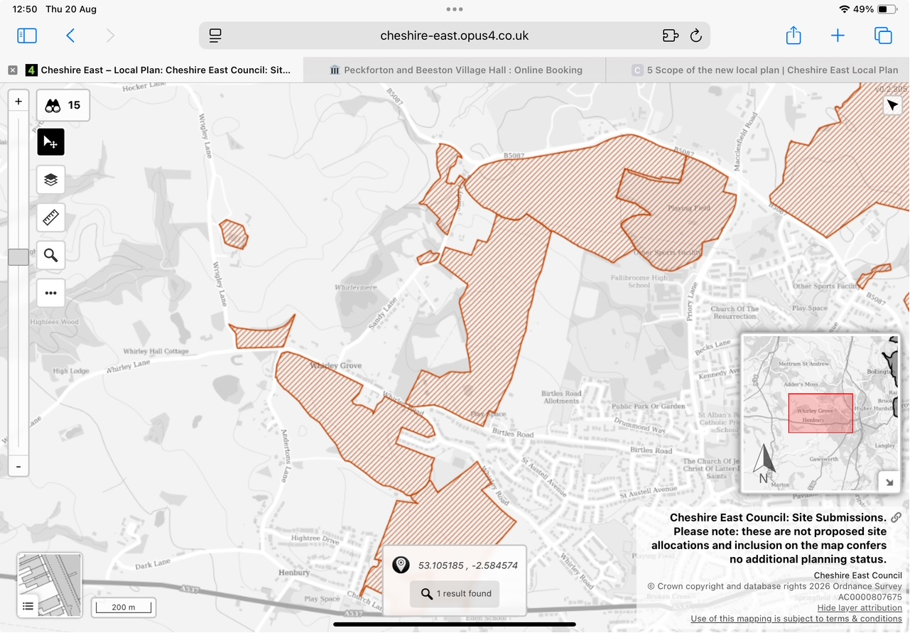
Figure 1. Cheshire East site-submissions map screenshot supplied by a resident. Check the live map for current references and boundaries.

2. Former Sandy Lane / Whirley Quarry landfill: a fundamental site-selection constraint
This is not a speculative assertion that a landfill exists. The Environment Agency public register identifies a waste operation at Whirley Quarry, Sandy Lane, and Cheshire East's own historic housing-land assessment explicitly recorded nearby land as directly on landfill.
Documented fact | Official / published evidence | Why it matters
Waste operation at Whirley Quarry | Environment Agency public register: BROCK LIMITED, Whirley Quarry, Sandy Lane, permit KP3092CX, A05 landfill taking non-biodegradable wastes. | Establishes a regulated landfill at the location; original permit and waste records should be obtained.
Historic licence reference | Public-register data links KP3092CX to pre-EA permit / licence reference 53470. | Provides a specific archive trail for the Council/EA to investigate.
Land directly on landfill | Cheshire East SHLAA 2012, site 3312, Land west of Roewoods Farm, Birtles Road: physical constraints include 'Located directly on landfill'. | Council evidence has previously treated landfill as a direct constraint on housing land in this immediate area.
Contaminated Land consultation | The same SHLAA entry identified 'Consultation with Contaminated Land Officer' under managing constraints. | Supports dealing with contamination at site-selection stage, not assuming it can be left entirely to a later application.
Ecological value of former landfill | Cheshire landscape evidence describes Sandy Lane Pit as a derelict landfill with ponds and terrestrial habitats supporting many amphibians including great crested newts. | Landfill remediation/development and ecology cannot sensibly be assessed in isolation.

2.1 What must be established before residential allocation
A historic landfill does not automatically prevent development. Equally, the mere possibility of later remediation is not evidence that residential allocation is suitable. For a sensitive residential end use, the Council should understand the source–pathway–receptor relationship sufficiently to judge suitability, viability and realistic development capacity.
- Original permit/licence documentation, variations, surrender/closure information and authorised waste categories.
- Available operator, Council and Environment Agency records identifying waste actually received, including any industrial/commercial waste streams.
- Historic and current borehole logs, monitoring wells and ground-investigation reports.
- Soil and made-ground chemistry, including contaminants of concern identified by the historic waste record.
- Landfill-gas monitoring for methane, carbon dioxide and other relevant gases, together with potential lateral migration pathways.
- Leachate records, groundwater levels, groundwater quality and inferred groundwater flow direction.
- Whether leachate or contaminated groundwater has been detected outside the recorded landfill footprint.
- Potential pathways towards submitted land around Sandy Lane, Birtles Road and Whirley.
- Effects of excavation, piling, foundations, dewatering and changes to surface-water drainage on existing contaminant pathways.
- Risks to construction workers, neighbouring occupiers and future residents.
- Likely remediation strategy, long-term monitoring requirements, abnormal development costs and whether these affect viability/deliverability.

2.2 Industrial waste / Ferodo-T&N issue: investigate, do not assume
There are historical local references to Ferodo/T&N industrial activity and disposal of friction-product waste in former pits. I do not assert that asbestos-containing Ferodo/T&N waste has been proven to have been deposited at Sandy Lane / Whirley Quarry. However, because the site is an established historic landfill and the precise historic waste stream is material to residential suitability, the Council and Environment Agency should check the original licence, operator records and archives specifically for Ferodo/T&N, asbestos-containing material and other industrial wastes.
Leachate wording: This representation does not claim that industrial contaminants are currently leaching into adjoining land. It asks the Council to establish, by records and investigation, whether leachate or contaminated groundwater exists and whether migration pathways extend beyond the landfill boundary.
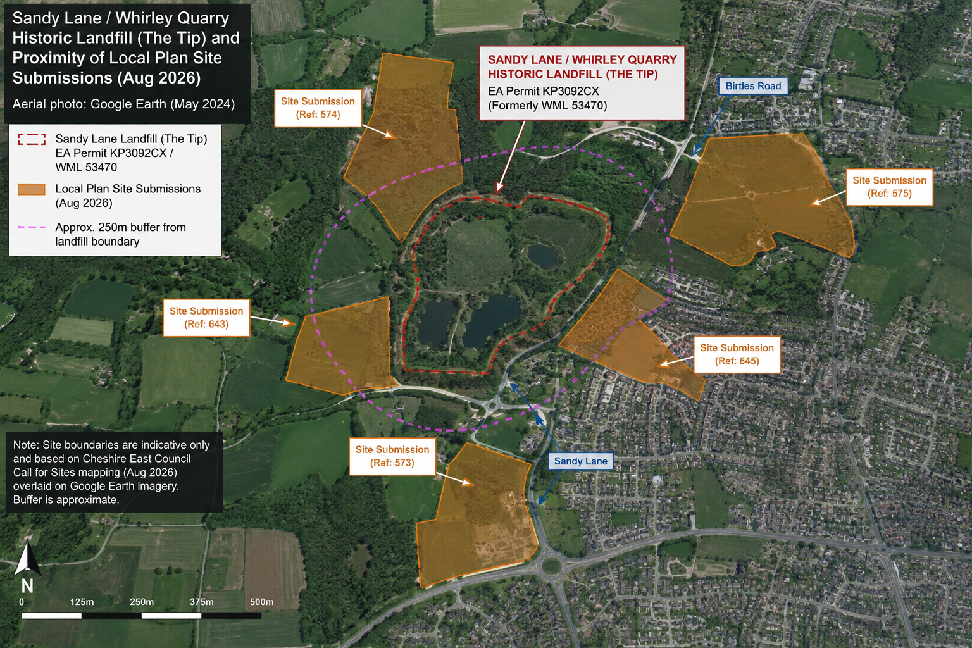
Figure 2. Resident-prepared aerial plan showing the historic landfill and nearby submitted parcels. Indicative only: official landfill/site boundaries should be obtained from Cheshire East and the Environment Agency.
Evidence source: Environment Agency public register; Cheshire East SHLAA 2012 Appendix entry 3312; Cheshire landscape-character evidence describing Sandy Lane Pit.

3. Housing need: publish the residual requirement for genuinely new land
Cheshire East's scoping document states that the new standard-method minimum is 2,530 dwellings per year. Over 15 years that is 37,950 homes. That is a housing-need starting point; it is not a demonstration that 37,950 homes require newly released countryside.
The Council should publish a transparent calculation:
- A. total new-Plan housing requirement;
- less B. existing permissions realistically completing within the new Plan period;
- less C. existing allocations realistically completing within the period;
- less D. homes already under construction that will complete within the period;
- less E. suitable brownfield, regeneration and under-used urban capacity;
- less F. justified windfall allowance;
- less G. other demonstrably sustainable urban capacity;
- equals H. residual requirement for genuinely additional land.
At the 31 March 2025 base date, published Cheshire East figures used in the accompanying resident evidence recorded 27,423 completions since April 2010 and 14,461 homes in identified remaining supply (9,277 allocated sites with permission; 3,146 other permitted sites; 2,038 allocated sites without permission). These figures span the existing plan framework and cannot simply be deducted wholesale from the new 15-year requirement; rather, they demonstrate why the overlap and residual calculation must be published.
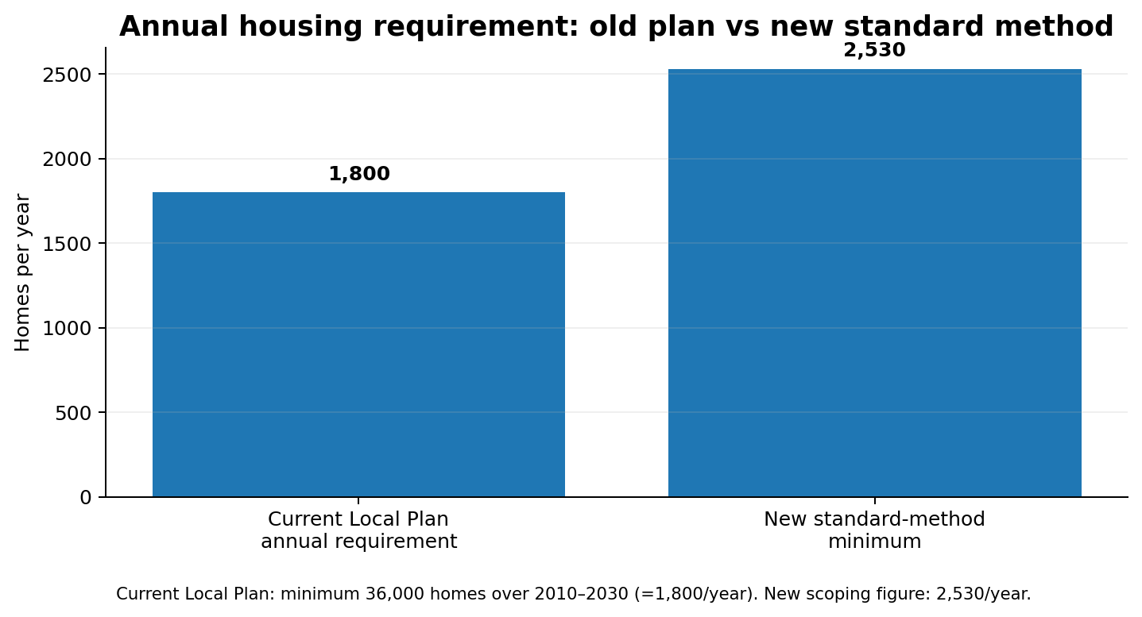
Figure 3. Current-plan annual requirement compared with the new standard-method minimum.
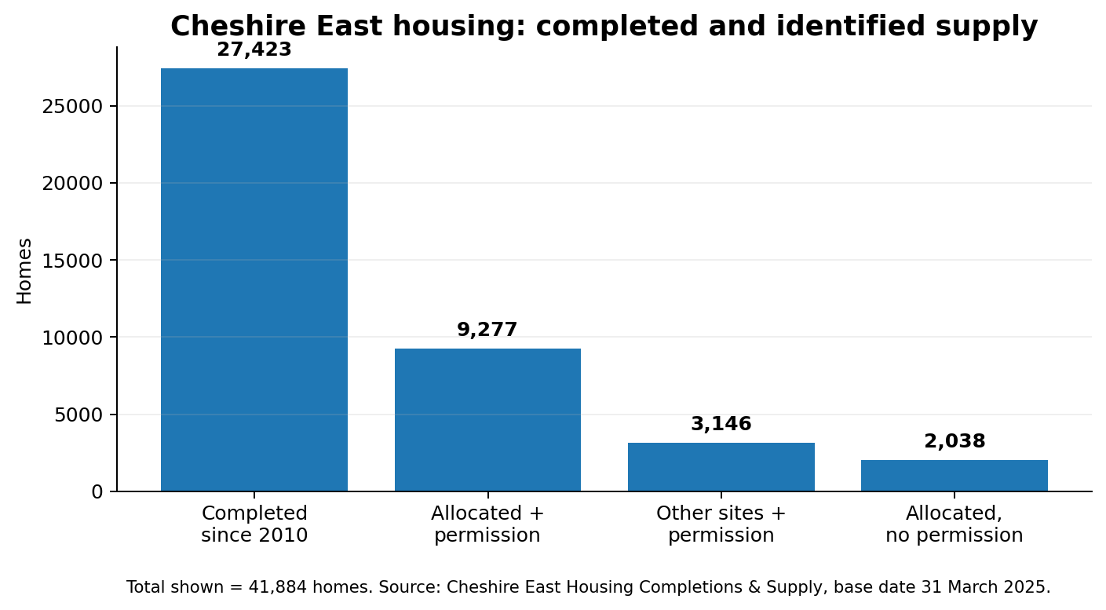
Figure 4. Housing completed and identified supply at the 31 March 2025 base date.
Evidence source: Cheshire East New Local Plan scoping document; Cheshire East Housing Monitoring / Housing Completions and Supply evidence, base date 31 March 2025.

4. Five-year supply: land identification and housing delivery are different questions
Cheshire East's April 2026 Strategic Planning Update reports 8,780 dwellings in the deliverable five-year supply, equivalent to 3.3 years against a five-year local housing need figure of 13,162. It also states that since the previous reporting period more homes had been built out than new planning consents granted, reducing the reported supply from 3.8 to 3.3 years.
A five-year supply shortfall has important planning consequences. It does not, however, answer how much land is already permitted or allocated but excluded from the five-year deliverability test, nor whether additional allocations would materially accelerate completions.
- Publish permitted-but-unbuilt homes by settlement and major site.
- Publish actual annual completion and occupation rates on major developments.
- Identify permissions/allocations excluded from the deliverable five-year supply and explain why.
- Separate constraints caused by infrastructure, phasing, developer build-out and market absorption from constraints caused by lack of land.
- Explain what evidence demonstrates that further allocations would increase annual delivery rather than simply increase the stock of allocated/permitted land.
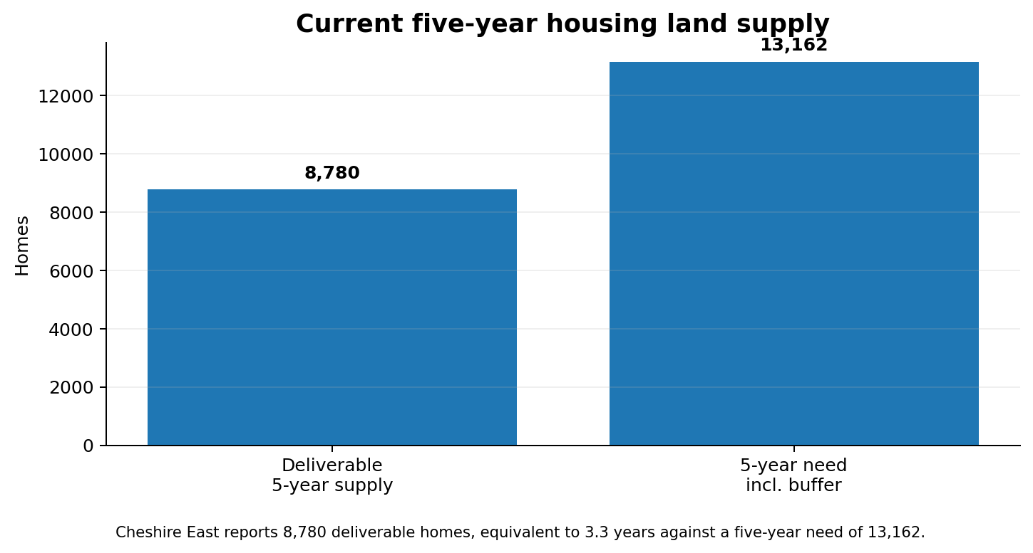
Figure 5. Cheshire East's reported five-year deliverable housing supply position.
Evidence source: Cheshire East Strategic Planning Update, April 2026.

5. Employment and housing must be planned together
Cheshire East's scoping document states that the current Local Plan sought at least 380 hectares of employment land between 2010 and 2030 to support average annual jobs growth of 0.7%. As at 31 March 2024, around 375 hectares remained available, over 112 hectares had been developed since 2010, and average annual jobs growth over the period was 1.3%.
This is evidence of employment growth, not evidence that no jobs have been created. The unresolved question for this Local Plan is where the next period of jobs growth will occur and how it relates spatially to large housing proposals around Macclesfield.
- Forecast additional jobs for Macclesfield and its immediate travel-to-work catchment.
- Expected sectors and major employment locations.
- Employment land required and the extent to which the existing 375 ha supply can meet future needs.
- Expected ratio between additional resident workers and local jobs.
- Commuting destinations and peak-hour travel patterns if employment is not nearby.
- Public-transport and road capacity implications of those commuting assumptions.
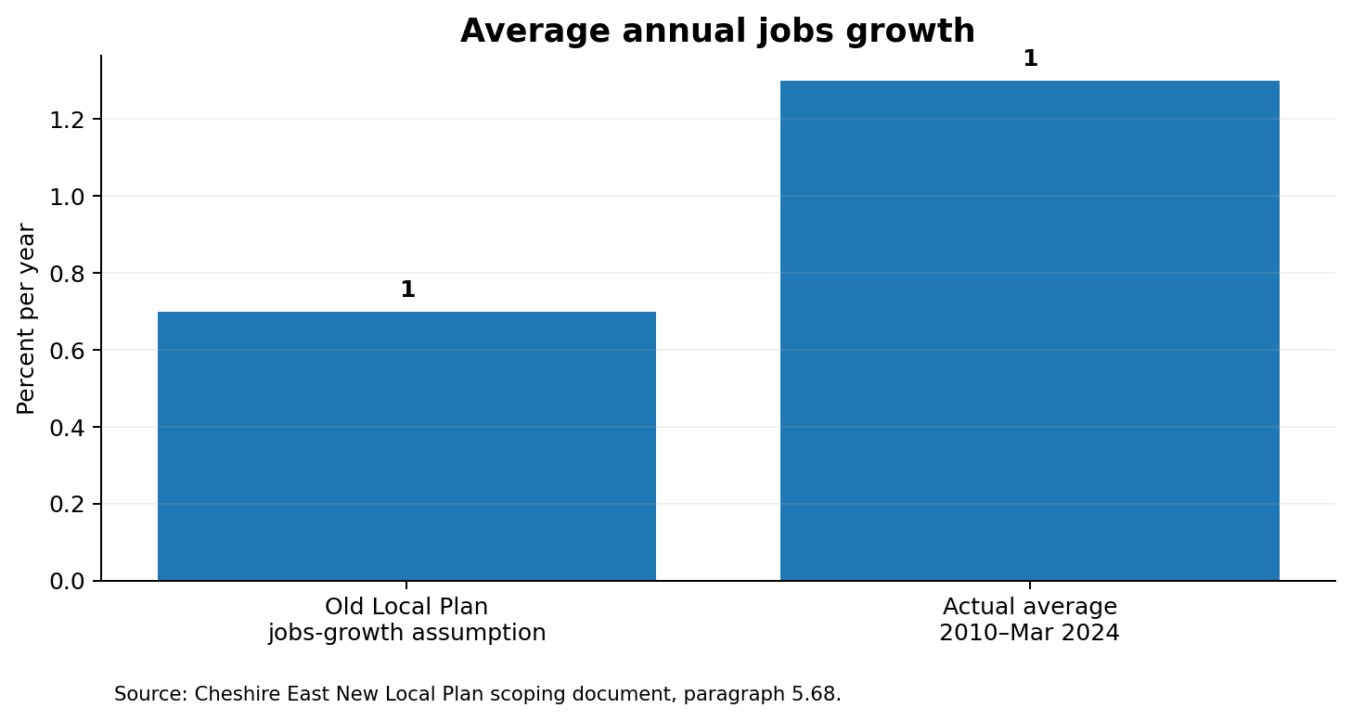
Figure 6. Average annual jobs growth: current Local Plan assumption versus actual 2010–March 2024.
Evidence source: Cheshire East New Local Plan scoping document, paragraphs 5.67–5.69.

6. Infrastructure capacity: evidence required before major growth is assumed
The Council's own scoping material recognises that infrastructure, jobs, commuting, services and facilities can influence the amount and distribution of development. For Henbury/Whirley, assessment should be cumulative and include existing residents, occupied recent development, permissions not yet occupied and any possible new allocations.
Infrastructure | Evidence required | Decision question
Schools | Catchment rolls, forecast pupils, committed-development yield, capacity and funded expansion. | Where will additional pupils go and when will places exist?
Healthcare | GP capacity/workforce; Macclesfield hospital/A&E and elective/outpatient demand; funded mitigation. | What additional capacity is required and is it deliverable before occupation?
Highways | Cumulative modelling of Whirley Road, Sandy Lane, Birtles Road, Wrigley Lane and key junctions. | What are peak-hour effects after committed and potential sites are combined?
Public transport | Bus frequency, rail access, walking/cycling routes and realistic mode share. | Would development create high car dependency?
Waste | Collection fleet/round capacity and household recycling capacity. | Can current services absorb the cumulative population?
Electricity | Distribution/substation headroom; reinforcement; EV/heat-pump load; programme and funding. | Can the network serve the development on time?
Water & wastewater | Potable-water headroom, foul sewer and treatment capacity; reinforcement. | What upgrades are required, who funds them and when?
Drainage | Catchment surface-water pathways, climate allowance and cumulative hardstanding. | Could development increase local/downstream flood risk?

Infrastructure mitigation should be specific: what is needed, cost, funding source, delivery body, trigger and operational date.

7. Ecology: the former landfill and surrounding countryside form connected habitat
Cheshire landscape evidence describes Sandy Lane Pit as a derelict landfill with ponds and terrestrial habitats supporting a large number of amphibians including great crested newts. Natural England's planning guidance identifies woodland, scrub and hedgerows as habitat where authorities should look for protected species including bats, breeding birds and badgers; grassland/pasture can support bats, badgers, birds and great crested newts.
Protected-species considerations are relevant to site allocations as well as later planning applications. Natural England's standing advice for species such as bats and badgers is a material planning consideration.
- Bats: survey roost potential, foraging habitat and commuting routes along hedgerows/tree lines; assess artificial lighting and preservation of dark corridors.
- Owls and other birds: assess nesting habitat and the role of grassland/pasture as hunting and feeding habitat even where nests are outside a submitted boundary.
- Badgers: assess setts where relevant, but also foraging areas, established movement routes, habitat fragmentation, disturbance and road risk.
- Great crested newts: assess ponds together with linked terrestrial habitat; the ecological constraint does not end at the pond edge.
- Hedgerows: assess age, continuity, species composition and function as connected ecological infrastructure, not merely metres retained.
- Mature/veteran trees: identify potential bat features, nesting value and landscape function early enough to influence site capacity and access.
- Cumulative ecology: assess the combined effect of multiple parcels, roads, lighting and drainage rather than each field in isolation.
Resident observations should be specific and genuine: approximate location, season, frequency and route. For example, repeated observation of bats travelling along the same hedgerow at dusk over several years is useful evidence of where professional survey effort should be focused. Residents should not disturb roosts, nests, ponds or badger setts.
Evidence source: Cheshire landscape-character evidence; Natural England / GOV.UK protected-species and standing-advice guidance.

8. Green Belt, landscape, settlement separation, heritage and agricultural land
The new Plan's spatial strategy should consider Green Belt purposes, landscape character, heritage, agricultural land, flood risk and brownfield/urban alternatives. In this locality, several submitted parcels could collectively become a substantial urban extension even if each parcel appears modest in isolation.
- Assess urban sprawl and countryside encroachment cumulatively.
- Assess physical and visual separation between Macclesfield and Henbury/Whirley.
- Map important landscape views and public-rights-of-way experience.
- Establish agricultural land classification and any loss of Best and Most Versatile land.
- Demonstrate reasonable brownfield, urban and less environmentally constrained alternatives before Green Belt release.
- Assess the significance and setting of Whirley Hall, a Grade II* listed building (National Heritage List entry 1329627), including cumulative changes to its rural setting and important views.

9. Consultation and community engagement
Cheshire East confirms that the scoping consultation runs from 21 July to 5pm on 1 September 2026. The Council has publicised the consultation online and allows residents to register for Local Plan notifications. I do not allege that the neighbour-notification rules applying to an individual planning application automatically apply to this scoping exercise.
Nevertheless, where concentrations of Call for Sites submissions immediately adjoin established communities, meaningful early engagement matters. I became aware of the scale of the submitted land principally through local residents. I therefore ask the Council to explain what targeted steps were taken to alert residents immediately around Henbury/Whirley/Sandy Lane/Birtles Road, and to ensure proactive direct engagement when actual site options or proposed allocations are considered.
The consultation also substantially overlaps the main summer-holiday period. Other published respondents have requested an extension on this basis. I ask the Council to consider whether additional time or additional local engagement is appropriate to maximise informed participation.
Evidence source: Cheshire East New Local Plan page; Cheshire East consultation portal; published scoping representation requesting an extension because of the summer-holiday timing.

10. Cumulative assessment: the central local planning issue
The submitted parcels should not be assessed as isolated fields. The correct planning question is what happens when existing commitments and plausible future allocations are combined across the locality.
The cumulative assessment should integrate:
- housing numbers and population;
- employment location and commuting;
- traffic, junctions, walking, cycling and public transport;
- schools, GPs, hospital and emergency/elective healthcare;
- waste and recycling;
- electricity network and substations;
- water, foul sewer, wastewater treatment, drainage and flood risk;
- historic landfill, industrial-waste records, soil contamination, landfill gas, leachate and groundwater pathways;
- great crested newts, bats, badgers, owls/breeding birds, hedgerows, mature trees, ponds, woodland, scrub and grassland;
- Green Belt purposes, landscape and settlement separation;
- Whirley Hall and wider heritage setting;
- agricultural land; and
- the interaction between these issues – for example roads removing hedges, lighting affecting bat corridors, or drainage changes affecting ponds and contaminant pathways.

11. Specific requests to Cheshire East
- Record this document and the covering email as my formal representation and objection to the 2026 New Local Plan Scoping Consultation.
- Cross-reference it to CFS26 590, CFS26 460 and CFS26 557 if those are confirmed as the current relevant references, and to any overlapping/successor submissions covering the same land.
- Treat the former Sandy Lane / Whirley Quarry landfill as a fundamental early site-selection constraint.
- Obtain and publish the relevant Environment Agency permit/licence and historic waste records, including records capable of identifying actual industrial/commercial waste streams.
- Ask the Council's Contaminated Land / Environmental Protection team to review the submitted sites before residential suitability is assumed.
- Establish whether landfill gas, leachate or contaminated groundwater is present and whether migration pathways could extend into adjoining submitted land.
- Investigate the Ferodo/T&N question from primary records without assuming that asbestos-containing waste at this particular landfill is either proven or disproven.
- Publish the residual housing-land calculation for the new Plan period after realistic existing supply and urban/brownfield capacity.
- Publish permitted-but-unbuilt and allocated-but-unbuilt housing information and explain the causes of the five-year deliverability shortfall.
- Publish Macclesfield-area employment forecasts, employment locations and commuting assumptions.
- Complete cumulative infrastructure-capacity evidence before concluding that major additional growth here is sustainable.
- Ensure protected-species, habitat-connectivity and appropriately timed ecological surveys inform site selection.
- Undertake cumulative Green Belt, settlement-separation, landscape, agricultural-land and heritage assessment, including Grade II* Whirley Hall.
- Explain targeted engagement with residents adjoining concentrations of submitted sites and ensure proactive notification at later site-allocation stages.
- Publish the evidence, scoring and reasons used to progress or reject individual sites.

Conclusion
I recognise the need for a sound Local Plan and for additional homes. However, on the evidence presently available I object to the potential residential allocation of the submitted land around Henbury, Whirley, Sandy Lane and Birtles Road. The combination of a documented historic landfill, unresolved waste-stream and contaminant-pathway questions, ecological value, infrastructure pressures, Green Belt/landscape sensitivity, heritage and cumulative development effects requires a much higher level of evidence before these sites can reasonably be treated as suitable.
In particular, the documented landfill should not be reduced to a note that can be dealt with after allocation. Cheshire East's own historic site evidence has already described nearby Birtles Road land as directly on landfill and called for Contaminated Land Officer involvement. I ask that the new Plan process now updates that evidence rigorously and transparently.
Please acknowledge receipt and confirm how this representation has been recorded and cross-referenced.
Yours faithfully,

Appendix A – Evidence table and principal sources
- Cheshire East – New Local Plan / consultation dates: https://www.cheshireeast.gov.uk/planning/spatial-planning/cheshire_east_local_plan/new-local-plan.aspx
- Cheshire East – Scoping document: Scope of the new Local Plan (housing/employment evidence): https://localplan.cheshireeast.gov.uk/scoping-consultation/5-scope-new-local-plan
- Cheshire East – Strategic Planning Update, April 2026 (8,780 homes; 3.3-year supply): https://www.cheshireeast.gov.uk/planning/spatial-planning/spatial-planning-update.aspx
- Cheshire East – Housing land supply / Housing Monitoring Update: https://www.cheshireeast.gov.uk/planning/spatial-planning/research_and_evidence/strategic_housing_land_assmnt/housing-land-supply.aspx
- Environment Agency public register – Waste Operations Permits search (BROCK LIMITED, Whirley Quarry, KP3092CX): https://environment.data.gov.uk/public-register/waste-operations/registration
- Cheshire East SHLAA 2012 Appendix – site 3312, Land west of Roewoods Farm, Birtles Road: https://www.cheshireeast.gov.uk/pdf/planning/spatial-planning/researchand-evidence/en-ldf-shlaa2012appd3156-3338.pdf
- Natural England / GOV.UK – Protected species and development advice: https://www.gov.uk/guidance/protected-species-and-development-advice-for-local-planning-authorities
- Natural England / GOV.UK – Bats standing advice: https://www.gov.uk/guidance/bats-advice-for-making-planning-decisions
- Natural England / GOV.UK – Badgers standing advice: https://www.gov.uk/guidance/badgers-advice-for-making-planning-decisions
- Historic England – Whirley Hall, Grade II*, list entry 1329627: https://historicengland.org.uk/listing/the-list/list-entry/1329627

Appendix B – Evidence to request / disclose
- Environment Agency permit KP3092CX and pre-EA licence 53470: original licence, conditions, variations, transfer/surrender records and waste categories.
- Historic operator returns, waste-transfer or acceptance records where retained.
- Council/EA borehole, groundwater, leachate and landfill-gas monitoring data for Sandy Lane / Whirley Quarry.
- Historic contaminated-land and ground-investigation reports for the landfill and adjoining land.
- Any Council/EA archival records referring to Ferodo/T&N or asbestos-containing/industrial friction-product waste at this particular site.
- Updated preliminary risk assessment / conceptual site model covering source, pathway and receptor relationships across the submitted parcels.
- Macclesfield settlement-level housing delivery trajectory and permitted-but-unbuilt schedule.
- Macclesfield-area employment forecasts and travel-to-work assumptions.
- School-place forecasts, healthcare capacity evidence, highways modelling, electricity headroom, water/sewer capacity and drainage evidence.
- Current ecological records and properly timed surveys for protected species and habitat connectivity.
Important evidential caution: The resident-prepared maps are orientation aids. The Council should use official cadastral/site-submission, Environment Agency landfill and survey data when making decisions. The representation deliberately distinguishes documented facts from matters requiring investigation.

