LOCAL PLAN SCOPING REPRESENTATION
Site HE2 - Land west of Sound Lane, Ravensmoor (1.03 ha)
Dear Strategic Planning Team,
Site Reference: HE 2.
Land to the west of Sound Lane, Ravensmoor.
Site Area: 1.03 hectares.

[Redacted] We understand that HE2 is a Call for Sites submission only: it is not an allocation, planning application or approved development, and no housing number or layout has been accepted. Please treat this letter as a scoping representation.
Having reviewed the proposed HE 2 site, Land to the west of Sound Lane, Ravensmoor, against the principles and objectives of the emerging Cheshire East Local Plan, we consider that there are significant and substantive reasons why the site should not be identified for residential development. Our concerns are not based on opposition to new housing in principle but on whether this particular site represents a sustainable, appropriate and deliverable location when assessed against the Plan’s requirements for accessibility, infrastructure, highway safety, landscape and settlement character, ecology, flood risk and the protection of the countryside. We therefore ask the Council to ensure that HE 2 is assessed objectively and comprehensively against these criteria, taking full account of the site’s existing constraints and its relationship with the surrounding settlement and highway network.
- Highway Safety, Infrastructure Strain and Road Capacity
Access to the site from Sound Lane requires particularly careful assessment. The existing rural highway network is not compatible with an urban housing site and should not be assumed to have capacity for a substantial residential development.
Sound Lane is a narrow rural lane which already carries substantial HGV, agricultural and general traffic. Vehicles frequently have difficulty passing, with traffic being forced onto verges. There have been numerous accidents and near misses in the surrounding area. Local reports highlight significant issues with high traffic volumes.
The cottages along Sound Lane in Ravensmoor from the crossroads down towards the bridge at Edleston Brook have little or no off-road parking; residents of these properties must therefore park their vehicles directly on Sound Lane effectively creating a single-track road and residents have suffered damage to their cars by passing vehicles due to the narrowness of the lane.
Local residents and representatives have raised serious concerns regarding heavy lorries using Sound Lane. The single-track rural road experiences ongoing issues with damaged verges, shaking properties and strained infrastructure.
The Sound & Broomhall Neighbourhood Plan itself records excessive heavy traffic, inadequate road widths, pinch points, visibility problems and previous accidents. It states that future housing should have only a minimal effect on traffic levels and that proposals for two or more homes should objectively assess their effects on road safety, pedestrians, cyclists, horse riders, parking and congestion.
Before HE 2 is considered further, the council should carefully assess the following points:
- measured road widths and visibility splays;
- current classified traffic and HGV counts;
- recorded collision and speed data;
- assessment of cumulative traffic from other developments;
- safe access for residents, emergency vehicles, refuse vehicles and deliveries;
- assessment of construction traffic; and
- provision for pedestrians, cyclists and horse riders, given the absence of suitable pavements and sustainable transport routes.
- Unsustainable Location and Pressure on Services
The site is located in open countryside at Ravensmoor and is poorly related to a settlement with the range of services normally expected to support a residential development of this nature. The area has limited public transport which is sporadic. Public footpaths are narrow in parts and often incomplete. There are no suitable cycle connections. Future residents would be substantially dependent on private cars for everyday needs. The Council’s assessment should therefore give significant weight to the site’s accessibility to shops, schools, healthcare, employment, public transport and other essential services such as sewerage, and utilities. It should consider the cumulative effects of all potential development in the wider area rather than examining HE 2 in isolation.
- Agricultural Land
Where such land is proposed for development, the Council's policy says the benefits of development need to clearly outweigh the economic and other benefits of losing the agricultural land. HE 2 is actively used for agricultural production, growing a crop of haylage annually which feeds local livestock in the winter and supports biodiversity. Cheshire East’s policy RUR 5 – Best and Most Versatile Agricultural Land seeks to avoid the loss of Grade 3a agricultural land such as this.

- Ecology
The site should be subject to a robust ecological assessment before any conclusion is reached that it is suitable for development. Resident observations indicate that a colony of Pipistrelle Bats live in the woodland along the brook. There is also badger activity on and around the site. Otters are known to travel along the brook and are mostly active at nighttime. An Ecological Survey should cover bats, badgers, otters, birds, hedgerows, mature trees, watercourses and habitat connectivity.
- Loss of Open Countryside, Rural Character and Landscape
The Council’s previous assessment of the site identified the area as open countryside status. HE 2 is open rural land, characterised by a sparse settlement pattern, agricultural fields, hedgerows, watercourses and long countryside views. Development of HE 2 would result in permanent loss of open countryside and would extend built development into a rural landscape, eroding the distinctive separation and rural character of the settlement.
Any assessment should address the adopted Neighbourhood Plan policies HOUS01 and HOUS02, including effects on openness, settlement pattern, historic field boundaries, hedgerows, trees, watercourses, wildlife habitats and landscape character.
The wider effect on the recognised character, tranquillity and environmental qualities of the open countryside should be of consideration.
- Residential Amenity
HE 2 adjoins the neighbouring property, Ivy Brook. Any assessment should carefully consider privacy, overlooking, outlook, daylight (sunlight), noise, lighting, disturbance and construction activity impact. Density and layout should reflect the site’s location in open countryside. The proximity of existing homes should be assessed under Neighbourhood Plan policy HOUS03 before the land is considered suitable or its potential capacity estimated. Any development should reflect and be proportionate to the settlement and well related to the existing built-up extent.
- Flood Risk and Drainage.
The Council’s previous assessment of the site identified flood risk constraints, including land within Flood Zone 3b along part of the southern boundary. Flood risk should therefore be assessed at site level, including surface water, drainage, ground water, climate change allowances and the potential effect of development on the neighbouring property and land. Development should not proceed on the assumption that drainage issues can be mitigated at a later stage.
- Access
HE 2 has the benefit of an agricultural easement: its agricultural land can be accessed via a single-track driveway over private land belonging to the adjacent property. There is currently no independent access from the HE 2 site to the public highway.
9. Previous Assessment of the Site
The Council has previously considered this land through its housing/site assessment work and identified significant concerns relating to accessibility, countryside impact, ecology and highway access.
Those previous findings should be carried forward into the new Local Plan evidence base rather than treating the 2024/2026 Call for Sites submission as a new site without regard to the site’s previous planning history.
10. Appropriate Scale of Development
If HE2 is nevertheless retained for further assessment, the Council should not rely upon historic theoretical capacity figures without undertaking a fresh assessment of what level of development is actually appropriate for this rural location.
Any assessment should be based on the site’s genuine environmental, landscape, highway and infrastructure capacity rather than maximising the number of dwellings that can physically be fitted onto the land.
  - Requested Action

- Please record this as a Local Plan scoping representation concerning HE 2.
- We would ask the Council to assess HE 2 against the above criteria and given the site’s rural location, accessibility limitations, highway constraints, landscape impact, ecological considerations and flood risk issues, to conclude that it is not an appropriate location for residential development.
- We also ask that the full evidence and reasoning supporting any decision to retain or reject HE 2 is published as part of the subsequent site selection process.
- Please acknowledge this response and retain our contact details for future consultation concerning HE 2.
- Please also confirm how neighbouring residents will be notified when the site assessment is published.
Yours faithfully,
Mike and Jane Abbatt

Appendix 1 - Road incidents, bridge damage and highway repairs
Period reviewed: 25 August 2021 to 25 August 2026. Distances are straight-line estimates from Ivy Brook at approximately 53.048887, -2.568330. The entries distinguish official data, parish-minute records and resident reports.
Date | Location and distance | Record and evidential status
18 Oct 2021-Mar 2022 | Sound Lane watercourse bridge beside southern HE2 boundary  Approx. 0.08 mi / 130 m | Council closure and parish-minute records show a prolonged closure while the bridge parapet and wall were rebuilt. Resident recollection links the damage to a collision, but the published order does not state the cause; causation should be confirmed with Cheshire East.
By 24 May 2022 | Sound Lane  Exact position not published | Parish minutes record patching work. The repaired section and whether it concerned verge, carriageway-edge or collision damage are not identified.
28 May 2024 | Sound Lane  Exact position not published | Parish-minutes police summary: 'RTC: Sound Lane, damage only.' No vehicle, damage or attendance details were published.
18 Sep 2024  15:12 | Baddiley Lane  0.87 mi / 1.40 km | Official DfT STATS19 record 2024070803994: two vehicles, including a light goods vehicle, travelling in opposite directions; one serious casualty.
19 Sep 2024  04:44 | Sound Lane near southern railway-bridge section  0.90 mi / 1.45 km | Official DfT STATS19 record 2024070805655: car overturned, left the carriageway and struck a pole; one slight casualty. Police attended. The collision occurred in darkness with no street lighting.
24 Sep 2024 | Sound Lane near railway bridge  Approx. 0.90 mi / 1.45 km | Parish-minutes police summary records a separate RTC. Consequences and injury status were not published.
3 Dec 2025 | Sound Lane, on a bend  Exact position not published | Parish minutes record a damage-only collision in which a van left the road and entered a field after loss of control on a bend.
Reported 4 Feb 2026 | Sound Lane railway-bridge approach  Approx. 0.90 mi / 1.45 km | Parish minutes state that an accident left the embankment unsafe and needing attention. The record does not establish whether this was the December incident or a separate collision.
12 Feb 2026 | Sound Lane  Exact position not published | Parish-minutes police summary records highway disruption after an HGV damaged a telegraph pole. No injury was reported in the published summary.
2 Mar 2026 | Sound Lane between Baddiley Lane and Wrenbury Heath Road | Road closure for Council hydroseeding, normally used to reinstate or stabilise an embankment or verge. A connection with the earlier accident-damaged approach is possible but is not stated in the closure notice.
14 Jul 2026  Approx. 05:50 | Marsh Lane bridge, east of Sound Lane crossroads  0.27 mi / 440 m | Official fire-service record: two-vehicle collision, temporary closure and three casualties treated by paramedics. A police account reported no serious injuries, pole damage and handover to highways officers at about 08:30.
30 Jul 2026 | Sound Lane/Marsh Lane crossroads  Approx. 0.2-0.3 mi | Resident-reported collision with police attendance. No public police, fire or news record has been located. It should be cited as verified only if supported by a police incident reference or information response.
Ongoing at 25 Aug 2026 | Sound Lane verge and carriageway edge adjoining HE2  0-0.1 mi | Resident-observed rutting, erosion and tarmac-edge damage where large vehicles leave the surfaced carriageway to pass. Parish minutes separately record Sound Lane verge damage and difficult HGV passing. Site-frontage evidence should be supported by dated photographs, measurements, coordinates and a Cheshire East traCE reference.
Interpretation note. DfT STATS19 data covers personal-injury collisions on public roads reported to the police. It does not include damage-only events or most verge and maintenance damage. The chronology should therefore inform, but not replace, a current transport assessment.

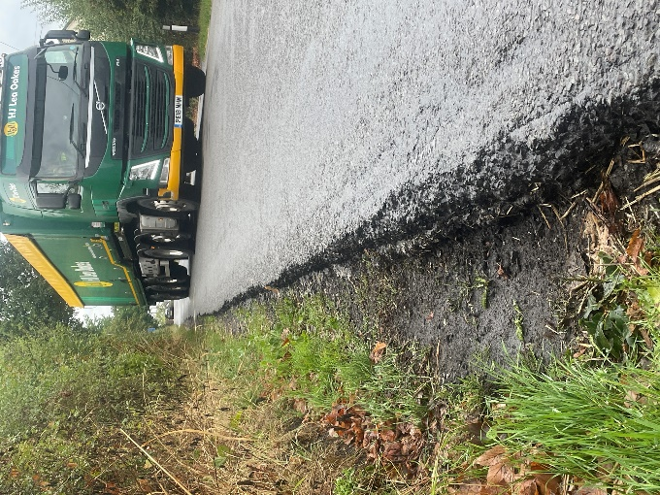  Damage to verges. | 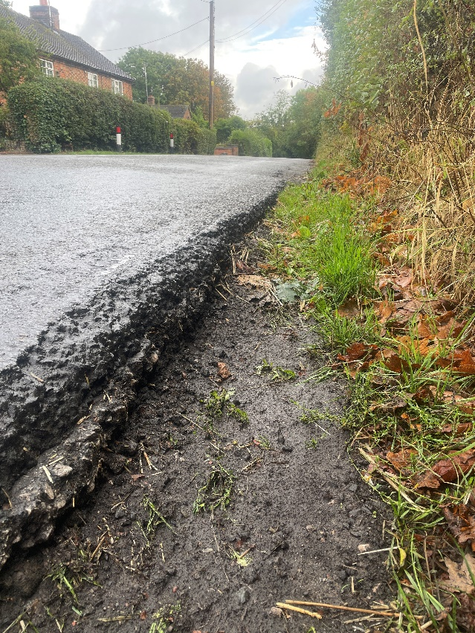
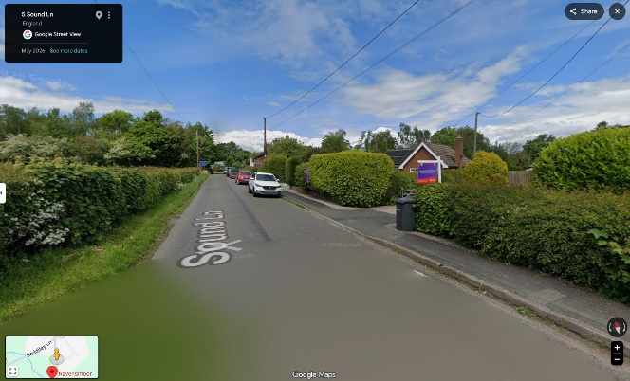 | 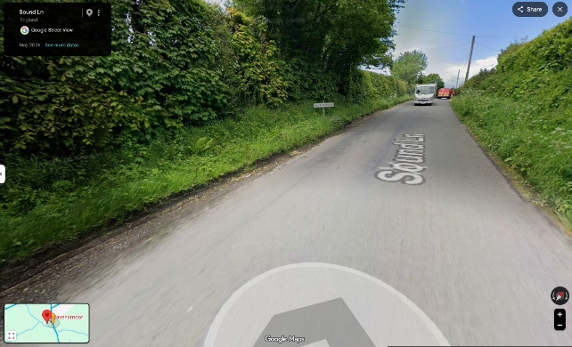
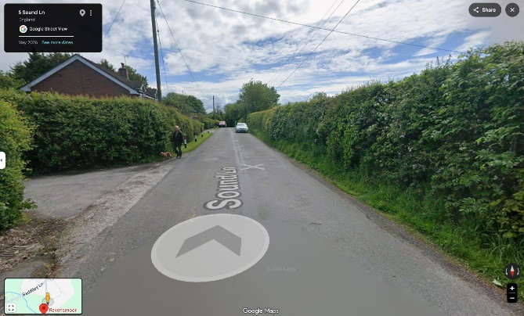 | Google map views dated May 2026:  Parking causing single track road.  Lack of pavements for pedestrians.

Published sources
- Cheshire East Council, HE2 Call for Sites mapping
- Cheshire East Council, Strategic Flood Risk Assessment
- Department for Transport, Road Safety Open Data (including 2024 STATS19 records 2024070803994 and 2024070805655)
- Cheshire East Council, explanation of road collision data
- Sound & District Parish Council, published minutes index
- Cheshire Fire and Rescue Service, Road traffic collision in Ravensmoor, 14 July 2026
- Nantwich News, police account of Marsh Lane collision, 14 July 2026
- Cheshire East Council, Policy INF 3: Highway safety and access
- Cheshire East Council, vehicular crossings and dropped kerbs
- Cheshire East Council, section 278/38 highway permits
- HM Land Registry, Practice guide 40: Land Registry plans
- HM Land Registry, Practice guide 62: easements
Additional local records cited in Appendix 1: Cheshire East temporary traffic and closure notices; Sound & District Parish Council minutes for March and May 2022, July and December 2024, December 2025, January-February-March-May 2026; and resident observations.

